Symmetry

Definition
# Source: AI Source: Provided by: [Data Path: Persons Table -> ID Column: 1, Name_En Column: Motasem Essam] -> From: [ChatGPT] on [7/25/2026]
Symmetry is a geometric relationship in which a figure, shape, or object has a balanced arrangement of its parts such that one part corresponds to another part according to a transformation.
A figure has symmetry when a transformation can map the figure onto itself while preserving its overall appearance.
Common types of geometric symmetry include:
- Line Symmetry
- Rotational Symmetry
- Point Symmetry
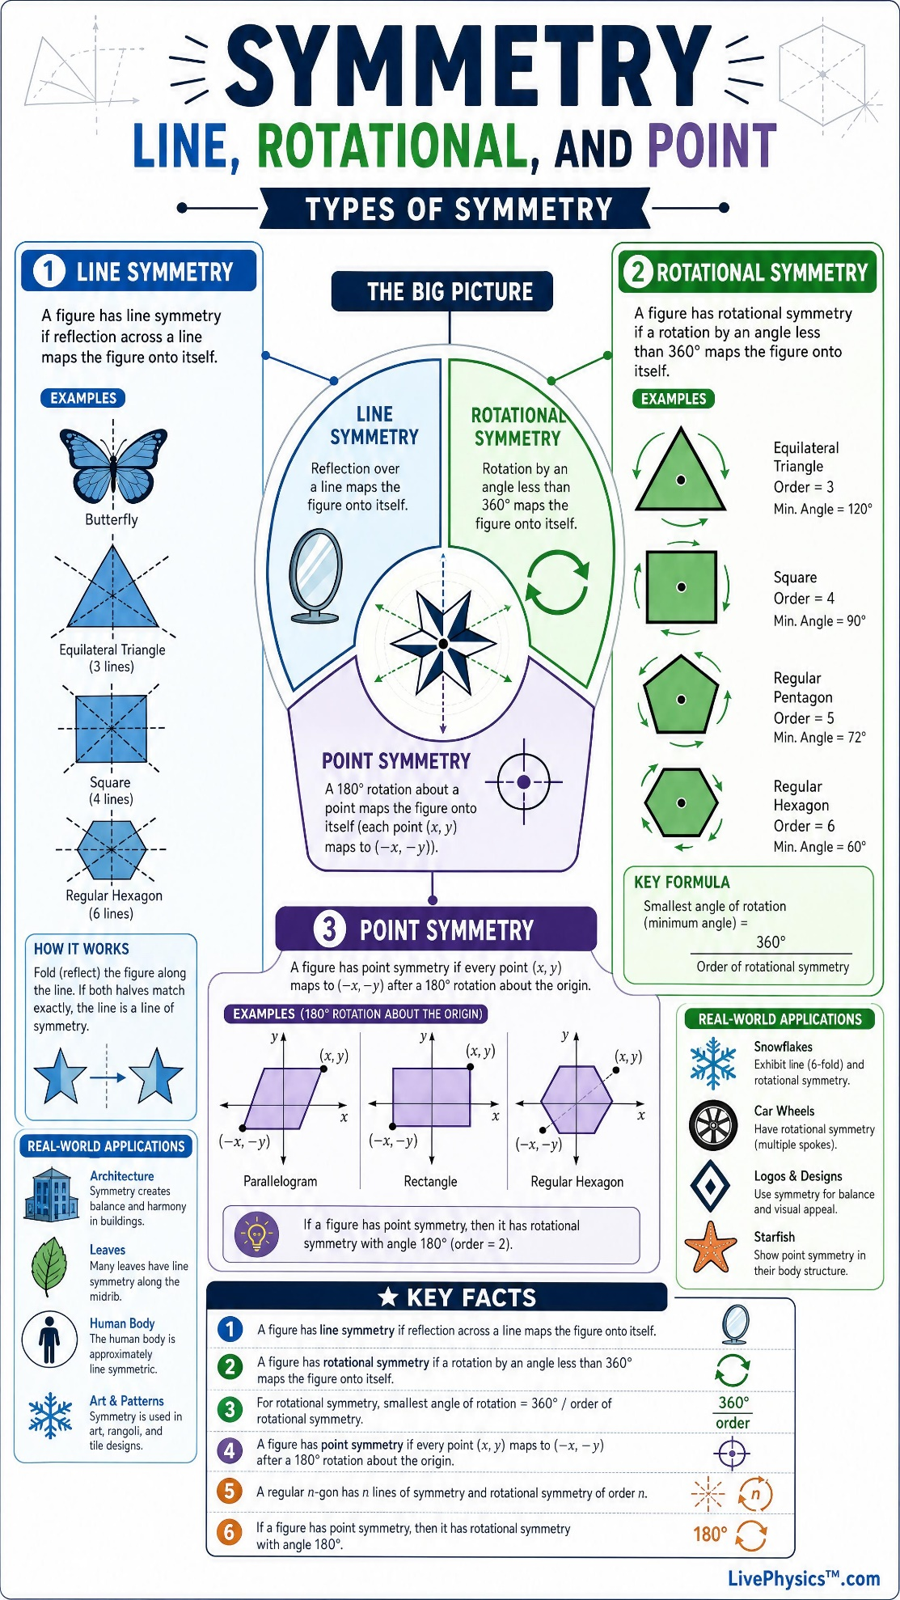
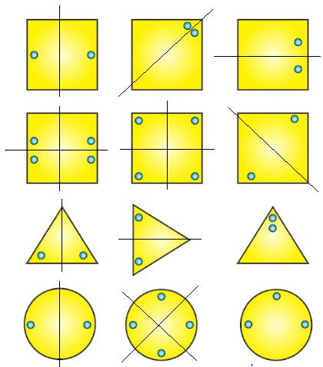
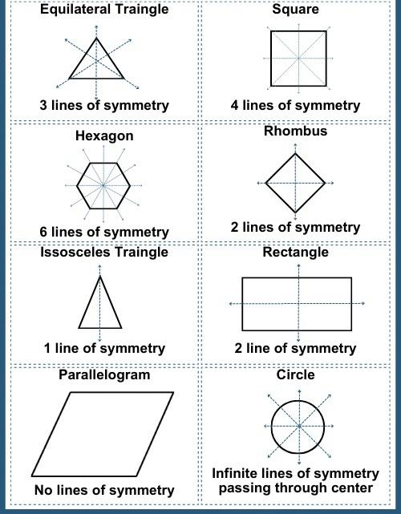
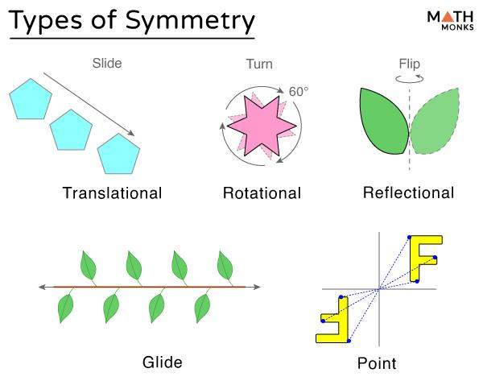
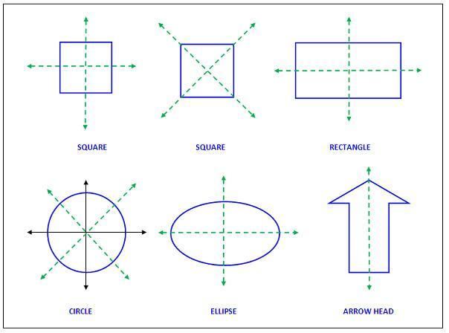
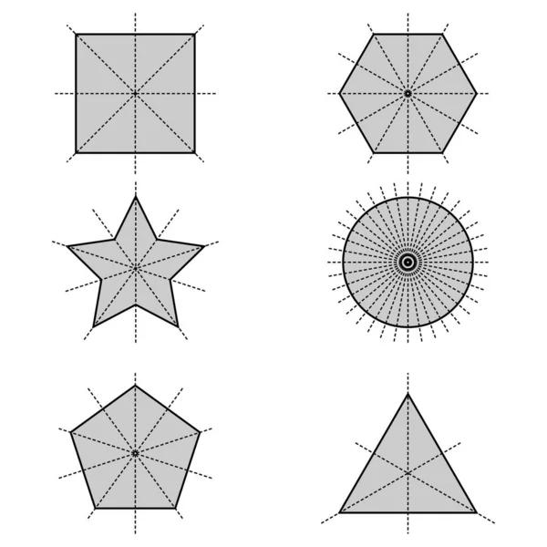

Purpose
# Source: AI Source: Provided by: [Data Path: Persons Table -> ID Column: 1, Name_En Column: Motasem Essam] -> From: [ChatGPT] on [7/25/2026]
Symmetry is used to:
- Identify balanced geometric figures.
- Analyze relationships between parts of a figure.
- Study geometric transformations.
- Identify repeated patterns.
- Understand congruence.
- Analyze shapes and structures.
- Create designs and patterns.
- Support architecture, engineering, art, and computer graphics.

Fundamental Idea of Symmetry
# Source: AI Source: Provided by: [Data Path: Persons Table -> ID Column: 1, Name_En Column: Motasem Essam] -> From: [ChatGPT] on [7/25/2026]
A figure is symmetric when one or more transformations can map the figure onto itself.
For example, a reflection across a line may produce the same figure:
$$\boxed{\text{Reflection}→\text{Same Figure}}$$
Similarly, a rotation through a particular angle may produce the same figure:
$$\boxed{\text{Rotation}→\text{Same Figure}}$$
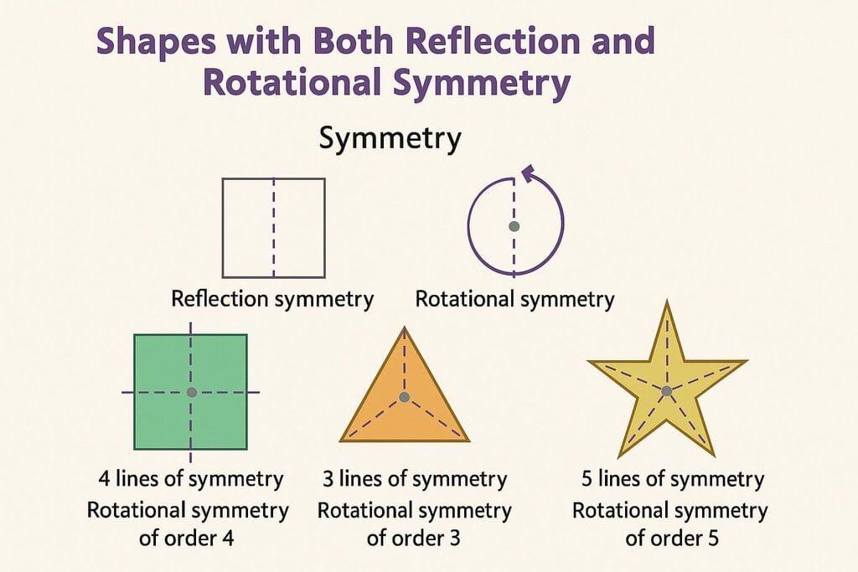
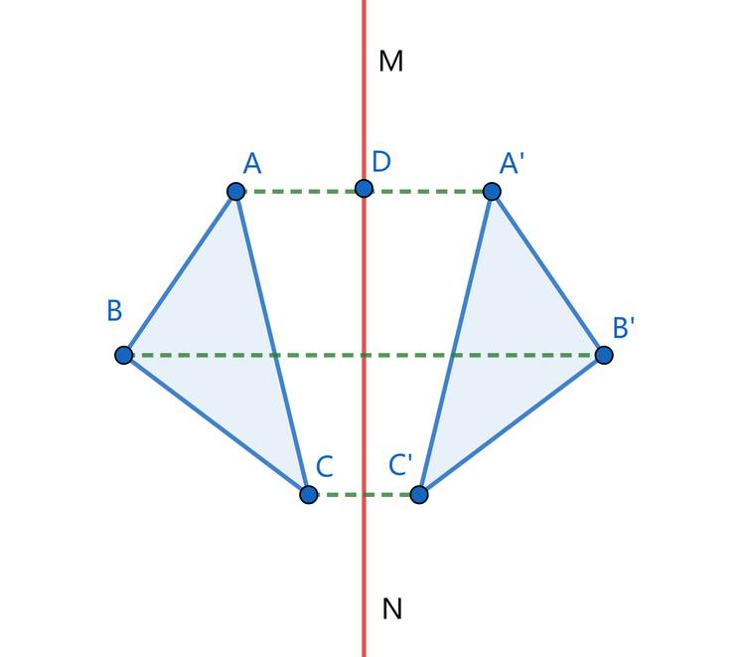
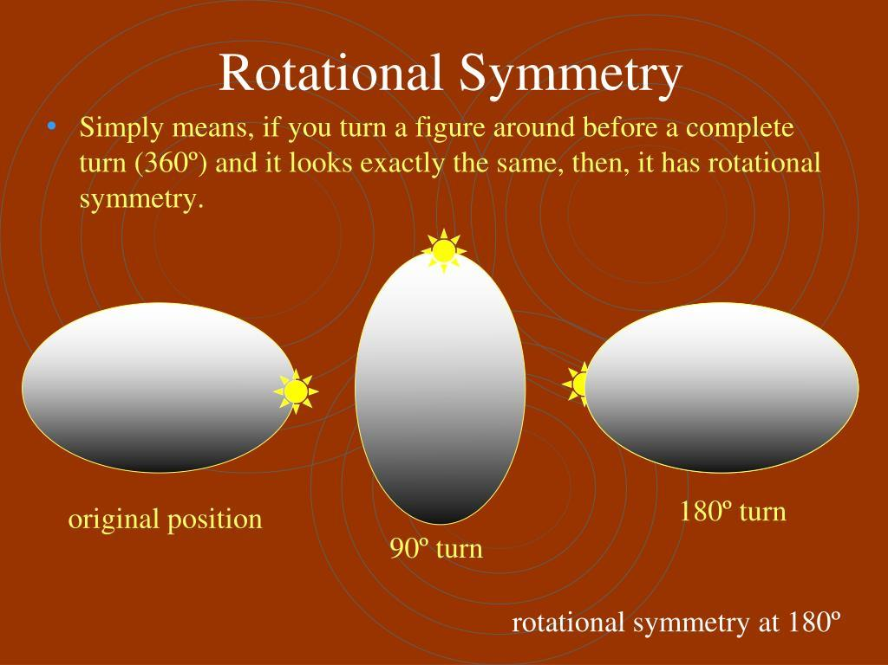
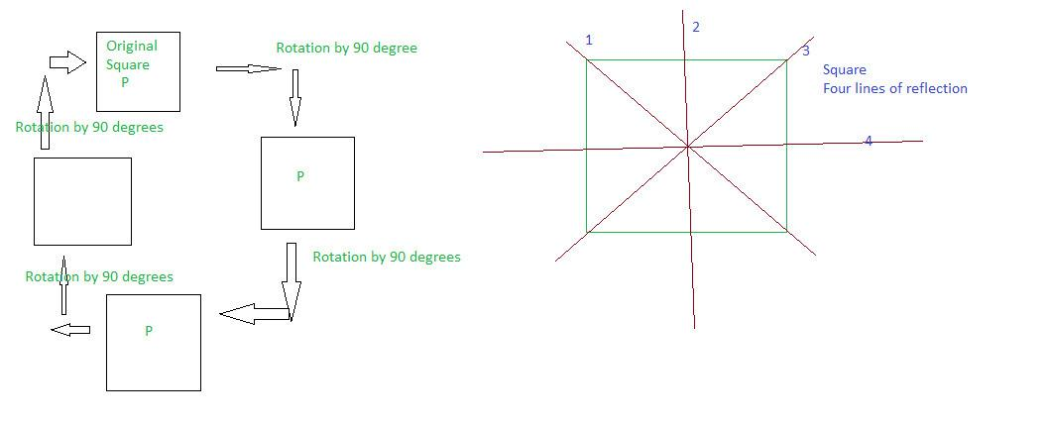
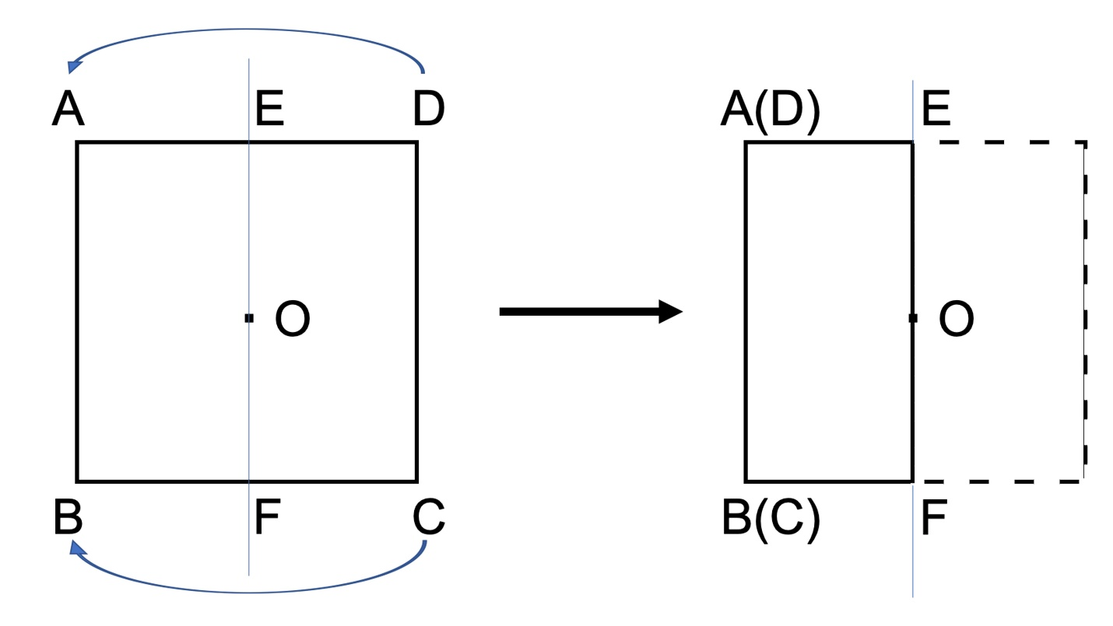

Types of Symmetry
# Source: AI Source: Provided by: [Data Path: Persons Table -> ID Column: 1, Name_En Column: Motasem Essam] -> From: [ChatGPT] on [7/25/2026]
The main types of symmetry commonly studied in geometry are:
- Line Symmetry
- Rotational Symmetry
- Point Symmetry

1. Line Symmetry
# Source: AI Source: Provided by: [Data Path: Persons Table -> ID Column: 1, Name_En Column: Motasem Essam] -> From: [ChatGPT] on [7/25/2026]
Definition
Line Symmetry occurs when a figure can be divided by a line into two matching parts that are mirror images of each other.
The line is called the line of symmetry or axis of symmetry.
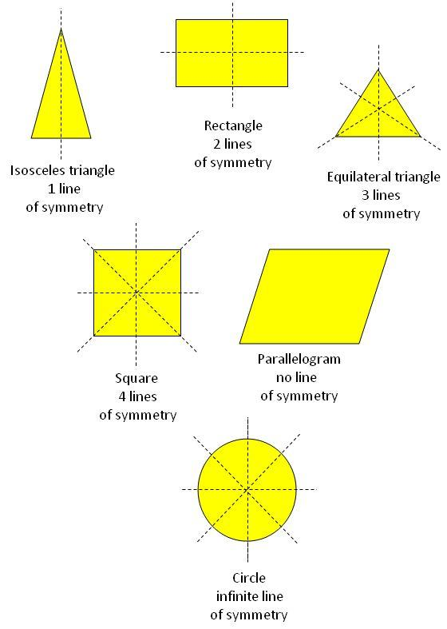
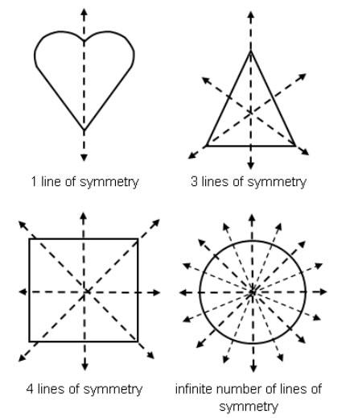
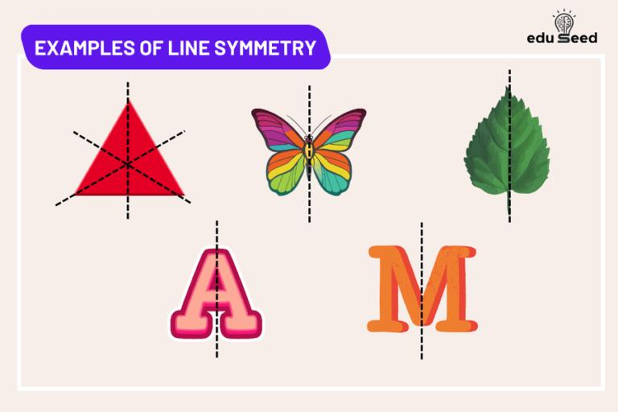
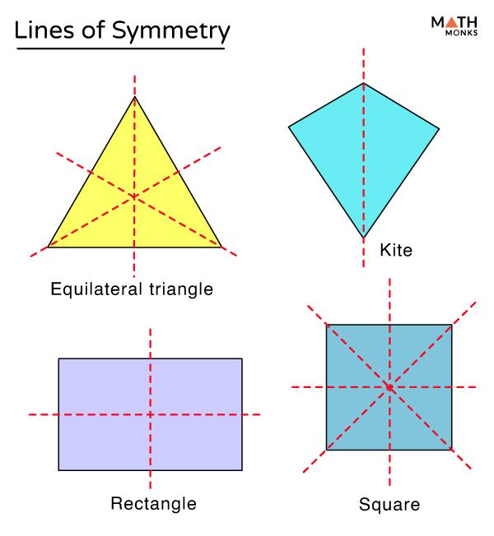
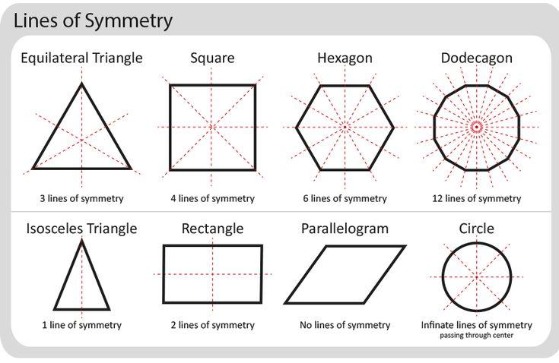
For example, a square has four lines of symmetry.
$$\boxed{\text{Square}=4\text{ lines of symmetry}}$$
A circle has infinitely many lines of symmetry.
$$\boxed{\text{Circle}=∞\text{ lines of symmetry}}$$

2. Rotational Symmetry
# Source: AI Source: Provided by: [Data Path: Persons Table -> ID Column: 1, Name_En Column: Motasem Essam] -> From: [ChatGPT] on [7/25/2026]
Definition
Rotational Symmetry occurs when a figure can be rotated about a fixed point by an angle less than (360^\circ) and still look exactly the same.
The fixed point is called the center of rotation.
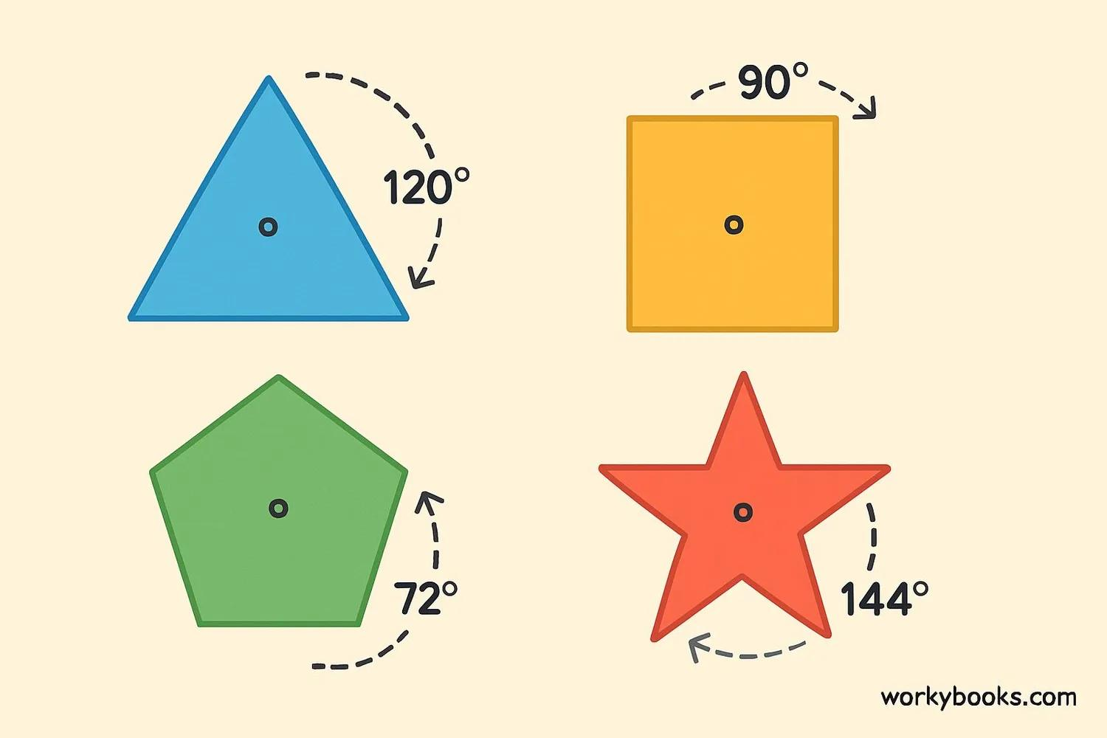
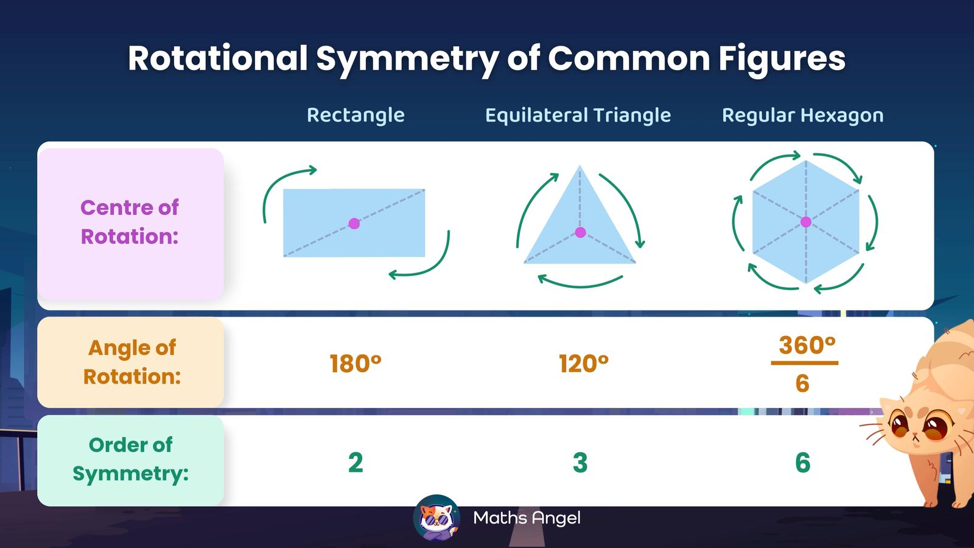
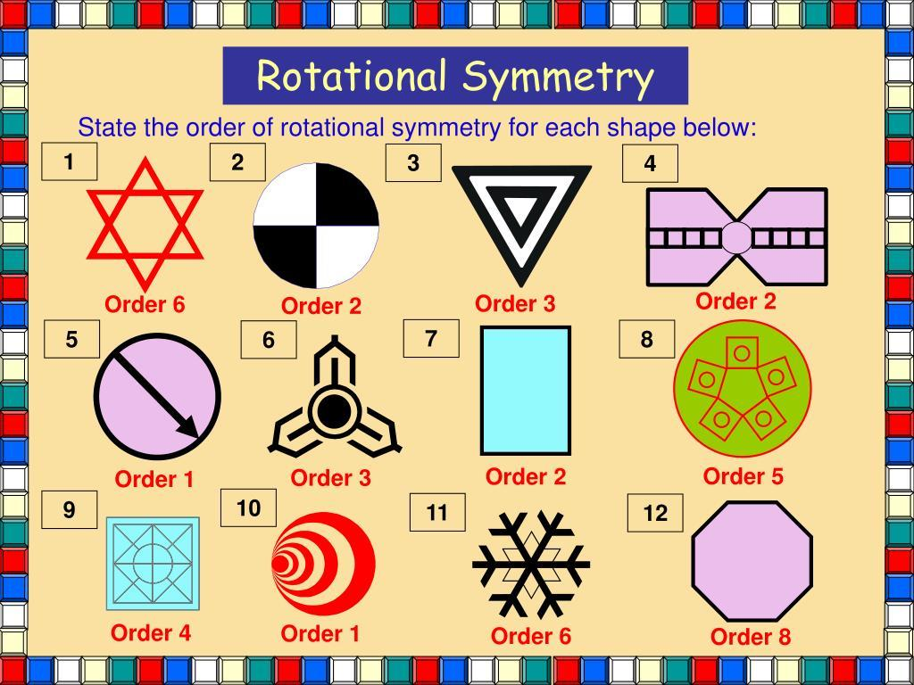
The number of times a figure matches itself during one complete rotation is called its order of rotational symmetry.
For example, a square has rotational symmetry of order:
$$\boxed{4}$$
because it matches itself four times during a complete ${360}^{∘}$ rotation.
The smallest angle of rotation is:
$$\frac{{360}^{∘}}{4}={90}^{∘}$$

3. Point Symmetry
# Source: AI Source: Provided by: [Data Path: Persons Table -> ID Column: 1, Name_En Column: Motasem Essam] -> From: [ChatGPT] on [7/25/2026]
Definition
Point Symmetry occurs when every point of a figure has a corresponding point on the opposite side of a fixed center at the same distance.
The fixed point is called the center of symmetry.
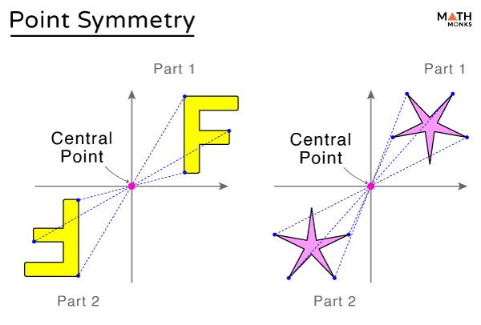
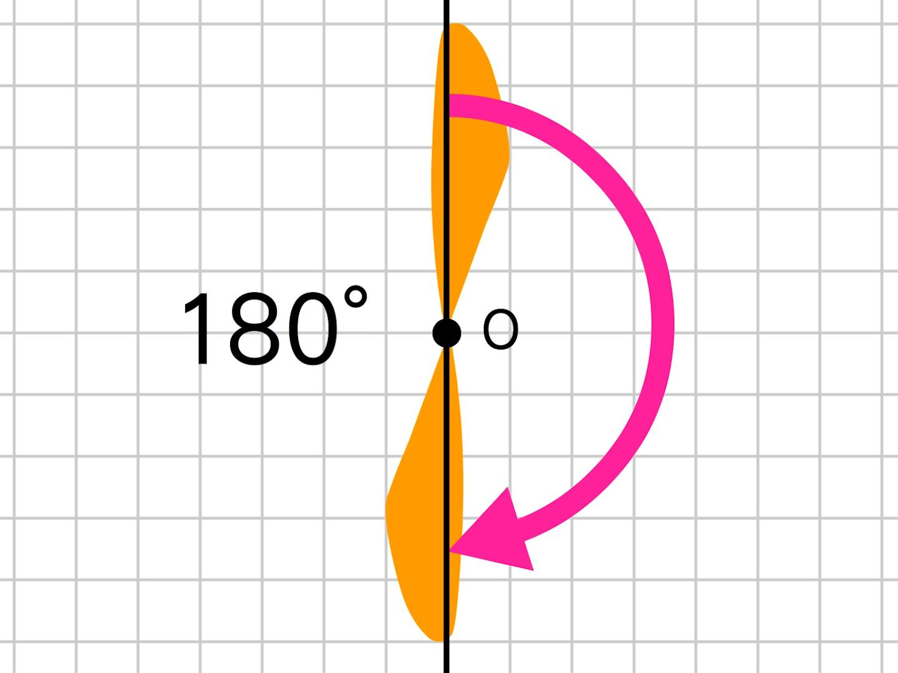
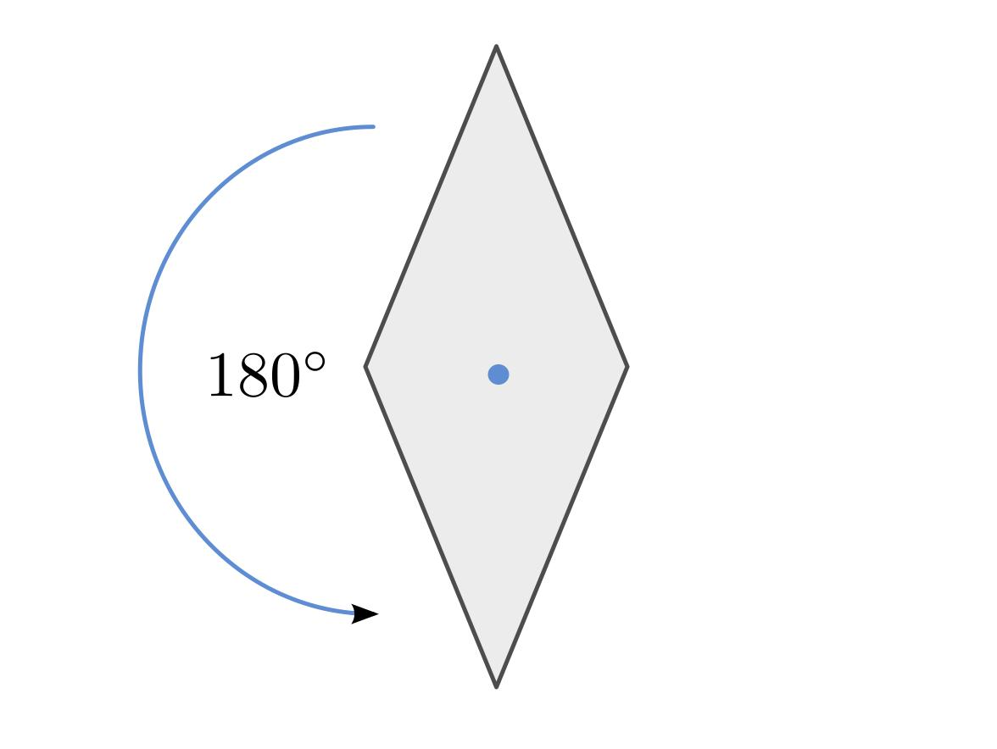
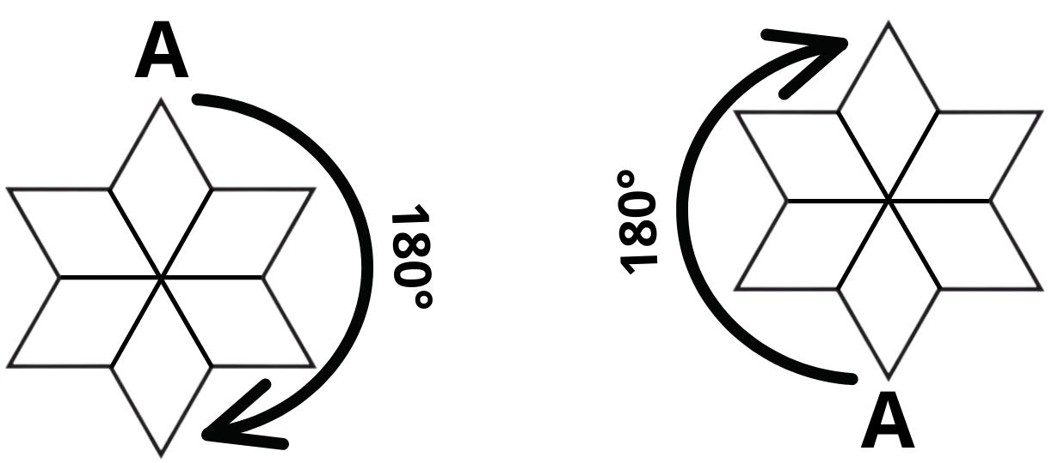
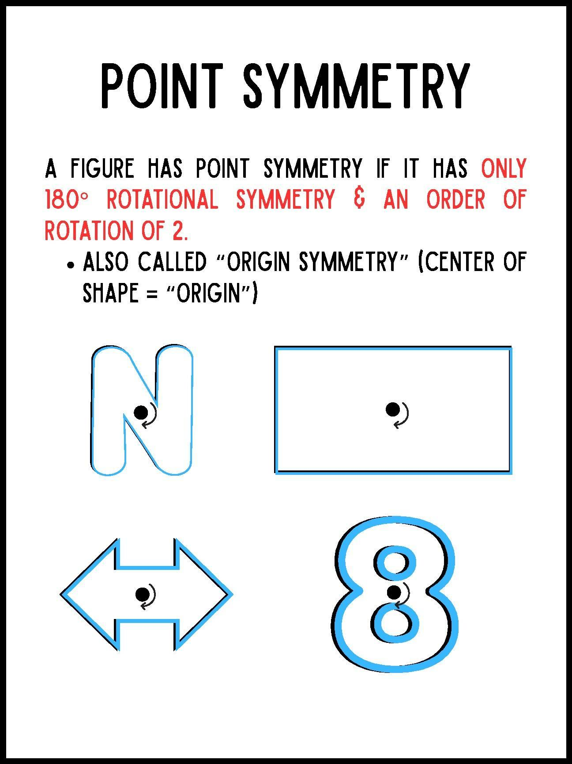
Point symmetry is equivalent to rotational symmetry of:
$$\boxed{{180}^{∘}}$$
For example, a parallelogram has point symmetry about the intersection of its diagonals.

Symmetry and Transformations
# Source: AI Source: Provided by: [Data Path: Persons Table -> ID Column: 1, Name_En Column: Motasem Essam] -> From: [ChatGPT] on [7/25/2026]
Symmetry is strongly connected to geometric transformations.
Line Symmetry
Uses:
$$\boxed{\text{Reflection}}$$
Rotational Symmetry
Uses:
$$\boxed{\text{Rotation}}$$
Point Symmetry
Uses:
$$\boxed{{180}^{∘}\text{ Rotation}}$$
Therefore, symmetry can be understood as a transformation that maps a figure onto itself.
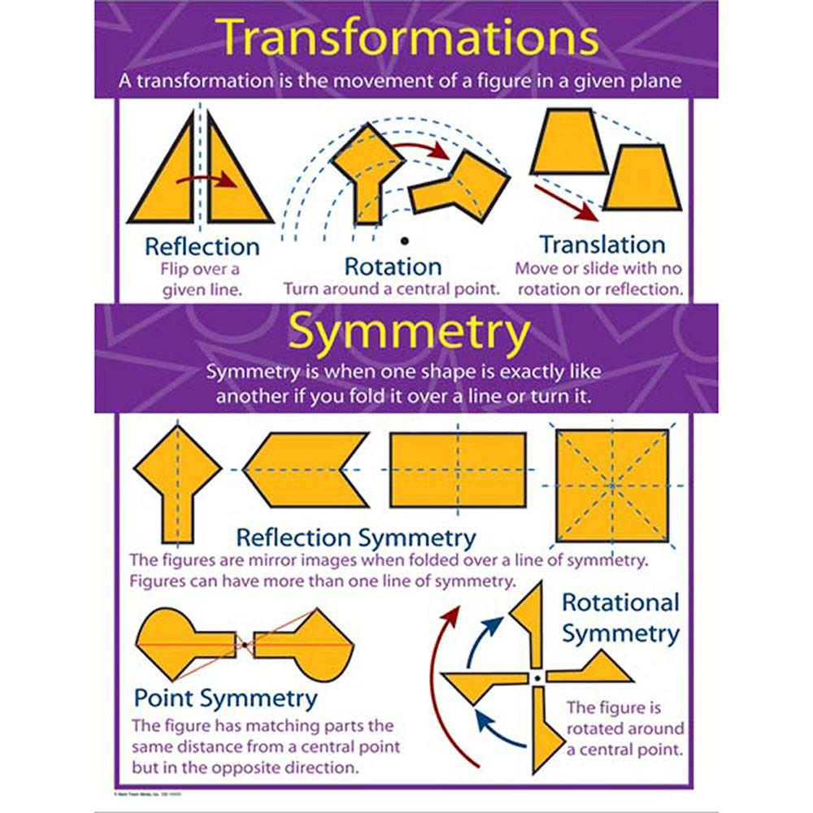
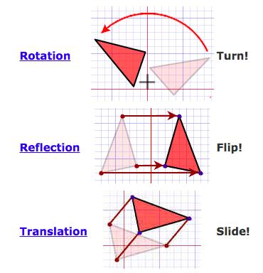
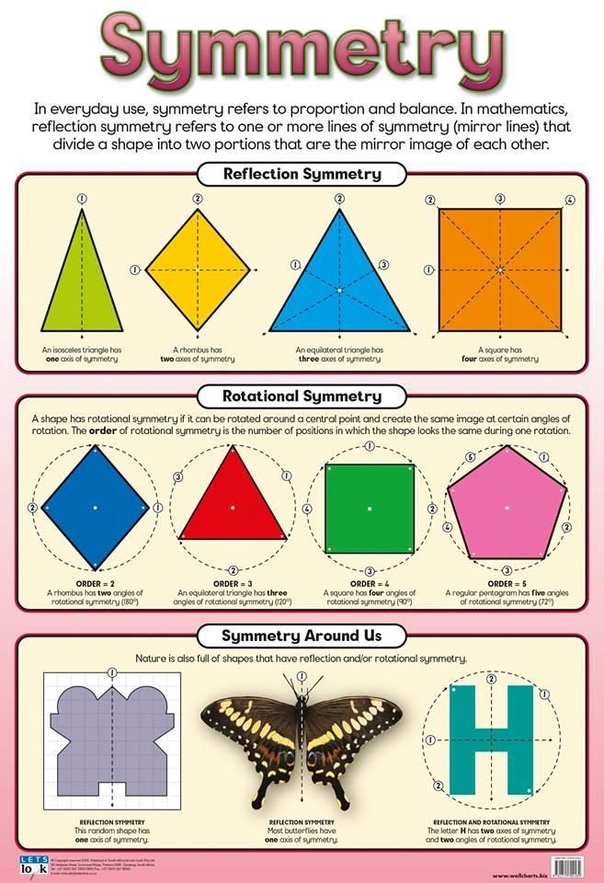

Line Symmetry Examples

Square
# Source: AI Source: Provided by: [Data Path: Persons Table -> ID Column: 1, Name_En Column: Motasem Essam] -> From: [ChatGPT] on [7/25/2026]
A square has four lines of symmetry:
- Vertical.
- Horizontal.
- Two diagonals.
$$\boxed{4}$$
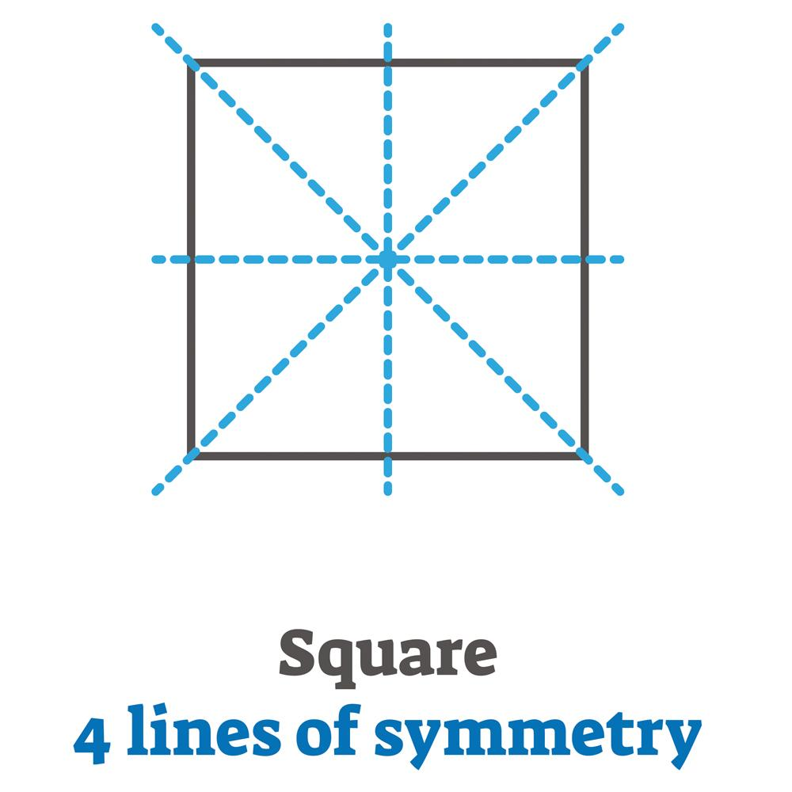
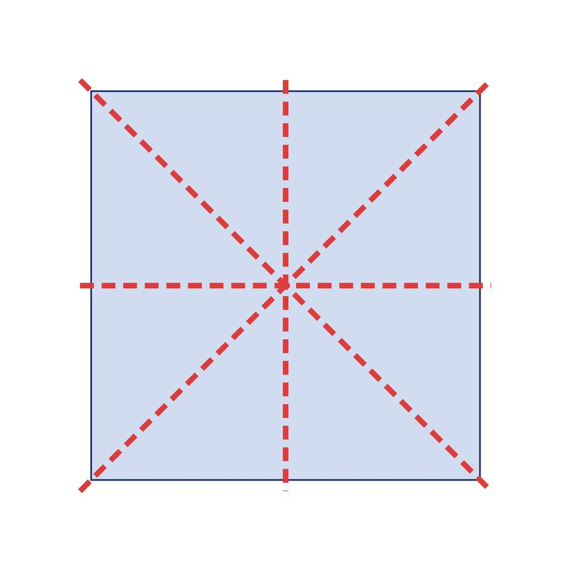
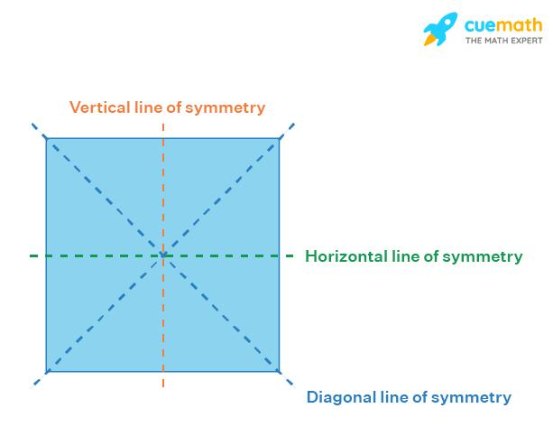
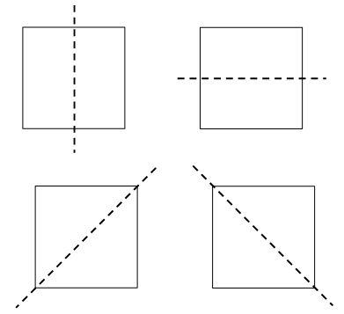
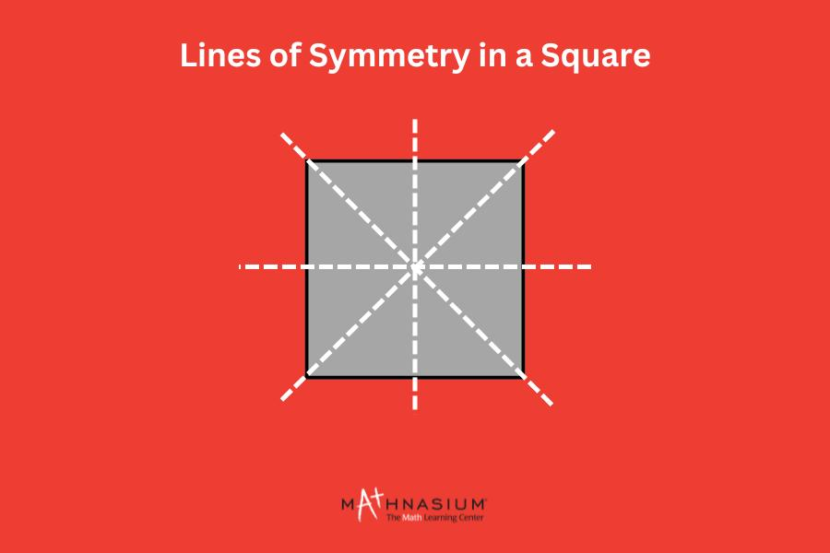

Rectangle
# Source: AI Source: Provided by: [Data Path: Persons Table -> ID Column: 1, Name_En Column: Motasem Essam] -> From: [ChatGPT] on [7/25/2026]
A rectangle has two lines of symmetry:
$$\boxed{2}$$
They pass through the horizontal and vertical centers.
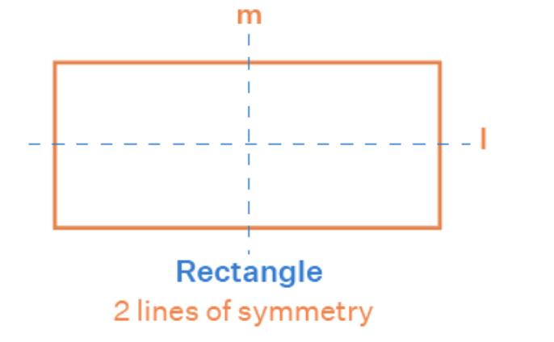
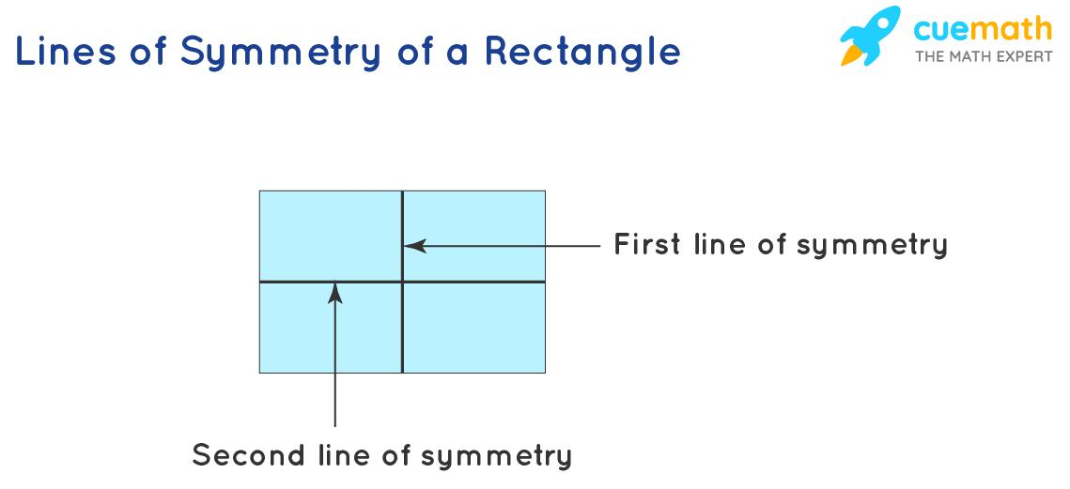
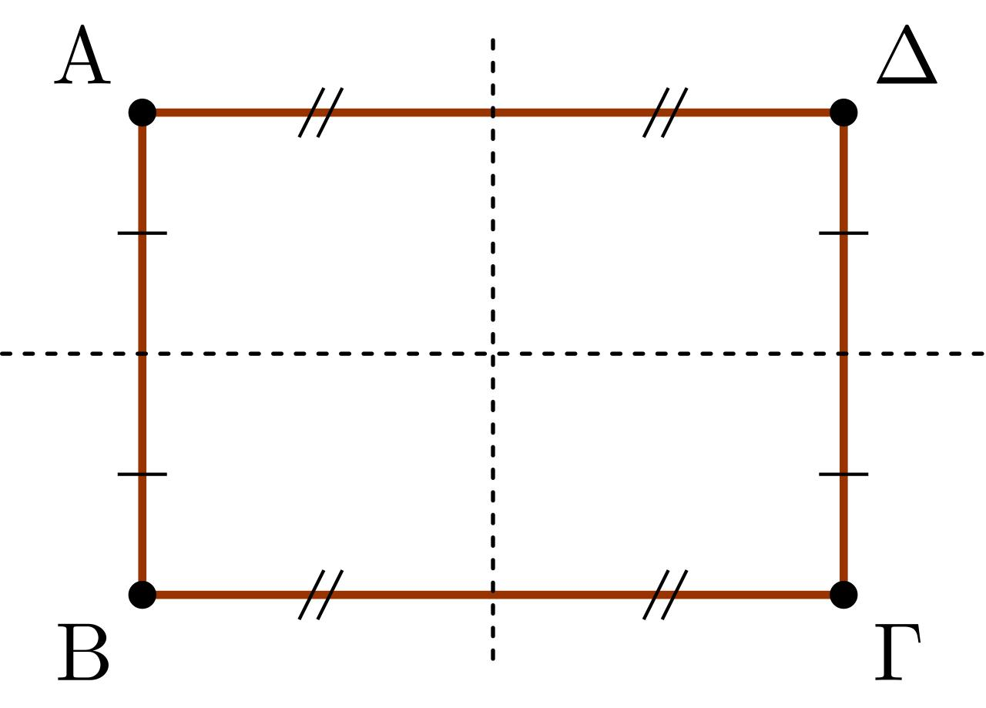
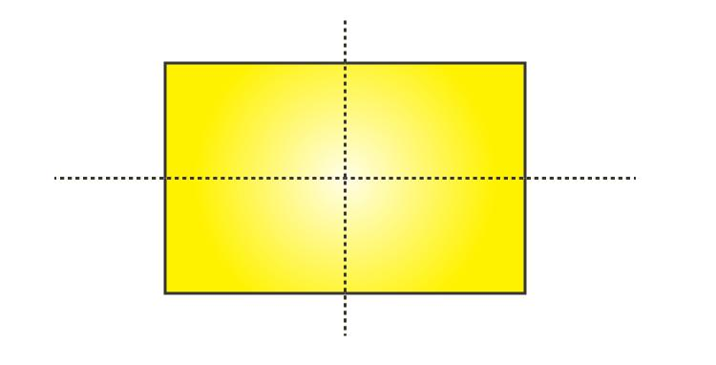
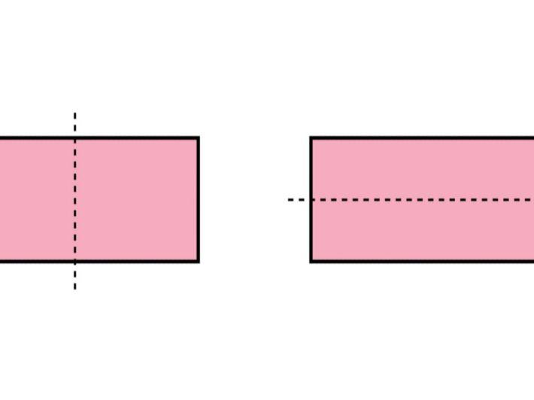

Equilateral Triangle
# Source: AI Source: Provided by: [Data Path: Persons Table -> ID Column: 1, Name_En Column: Motasem Essam] -> From: [ChatGPT] on [7/25/2026]
An equilateral triangle has:
$$\boxed{3}$$
lines of symmetry.
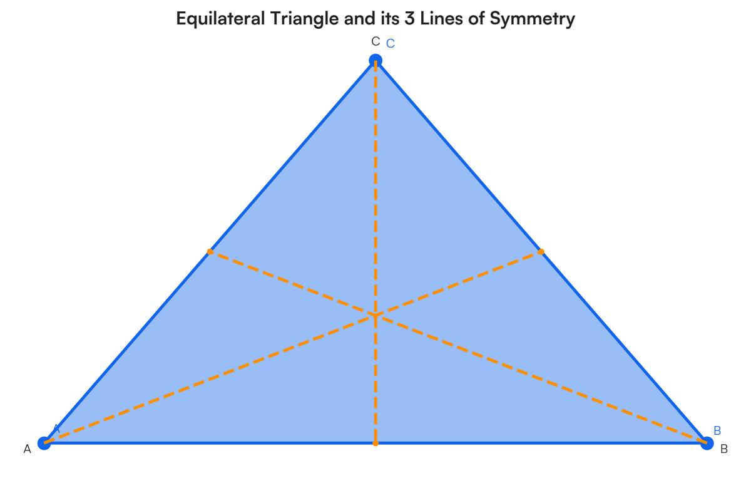
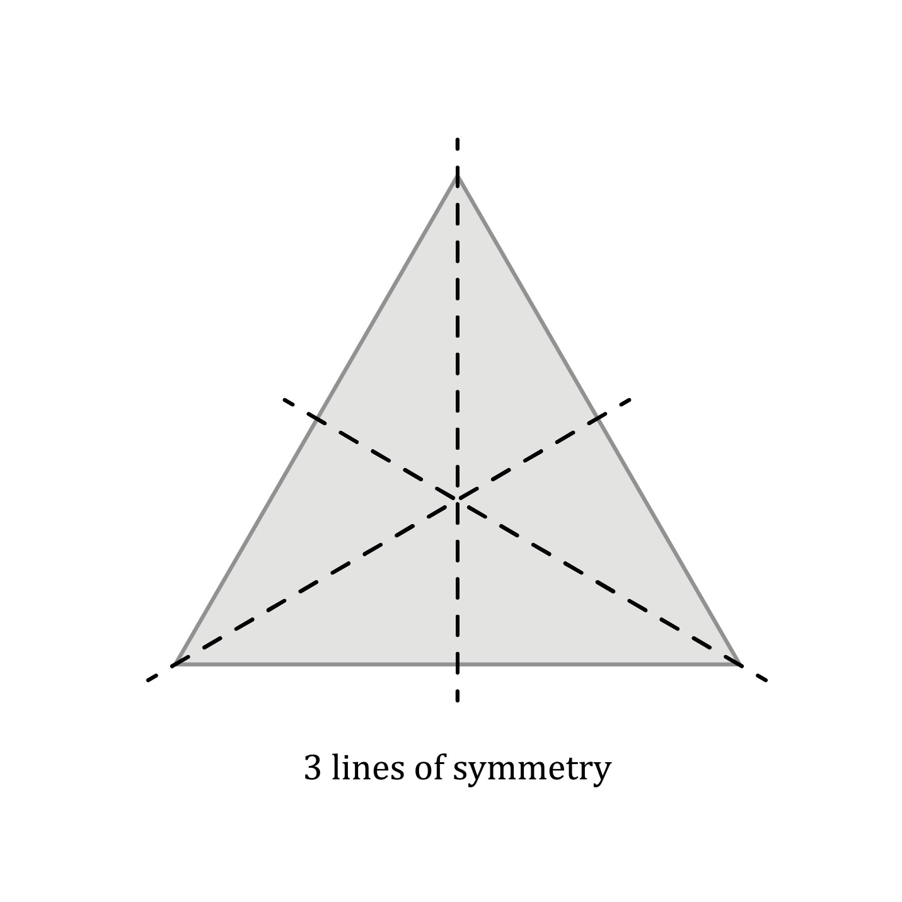
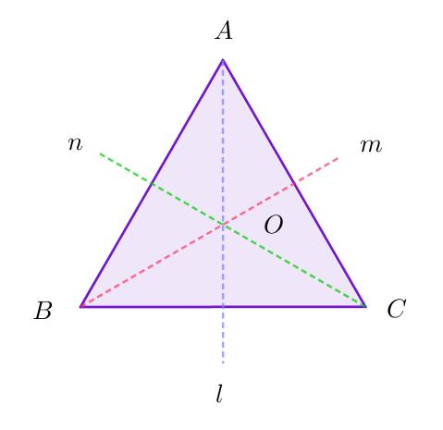
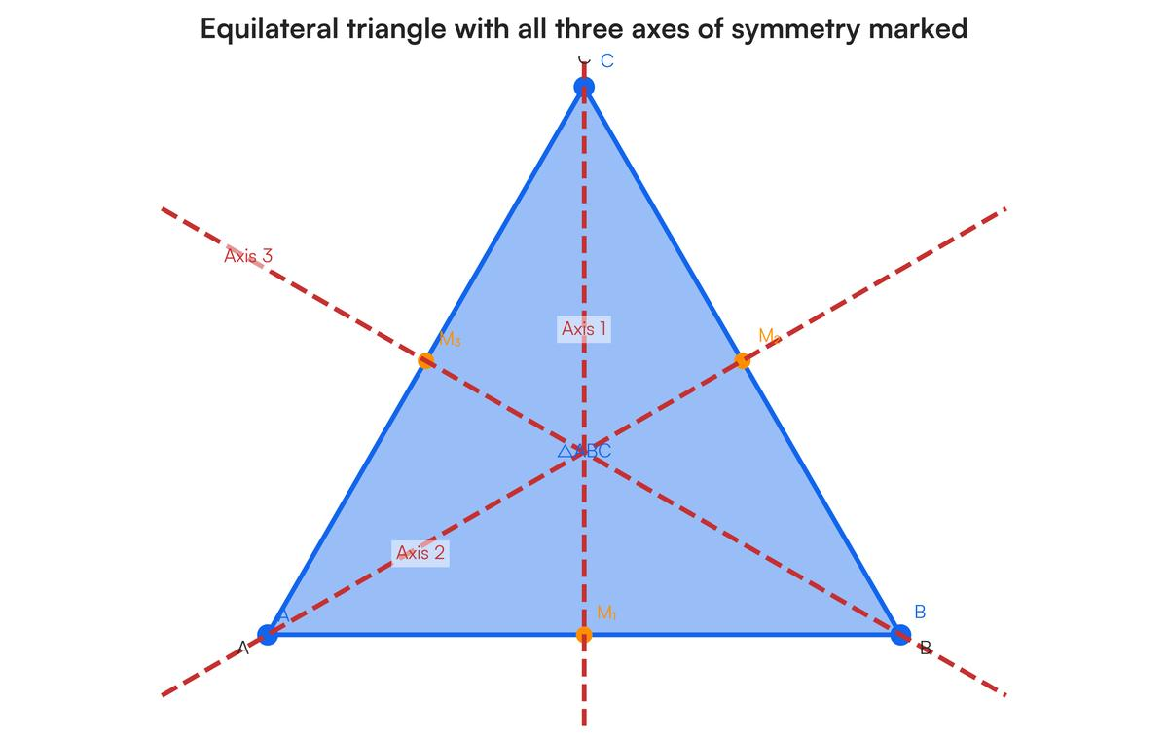

Circle
# Source: AI Source: Provided by: [Data Path: Persons Table -> ID Column: 1, Name_En Column: Motasem Essam] -> From: [ChatGPT] on [7/25/2026]
A circle has infinitely many lines of symmetry:
$$\boxed{∞}$$
Every diameter is a line of symmetry.
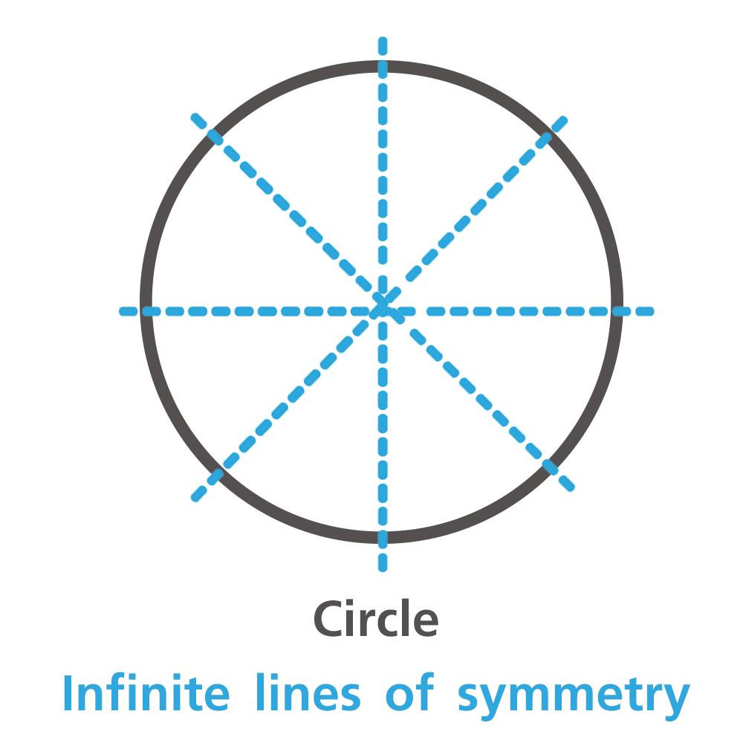
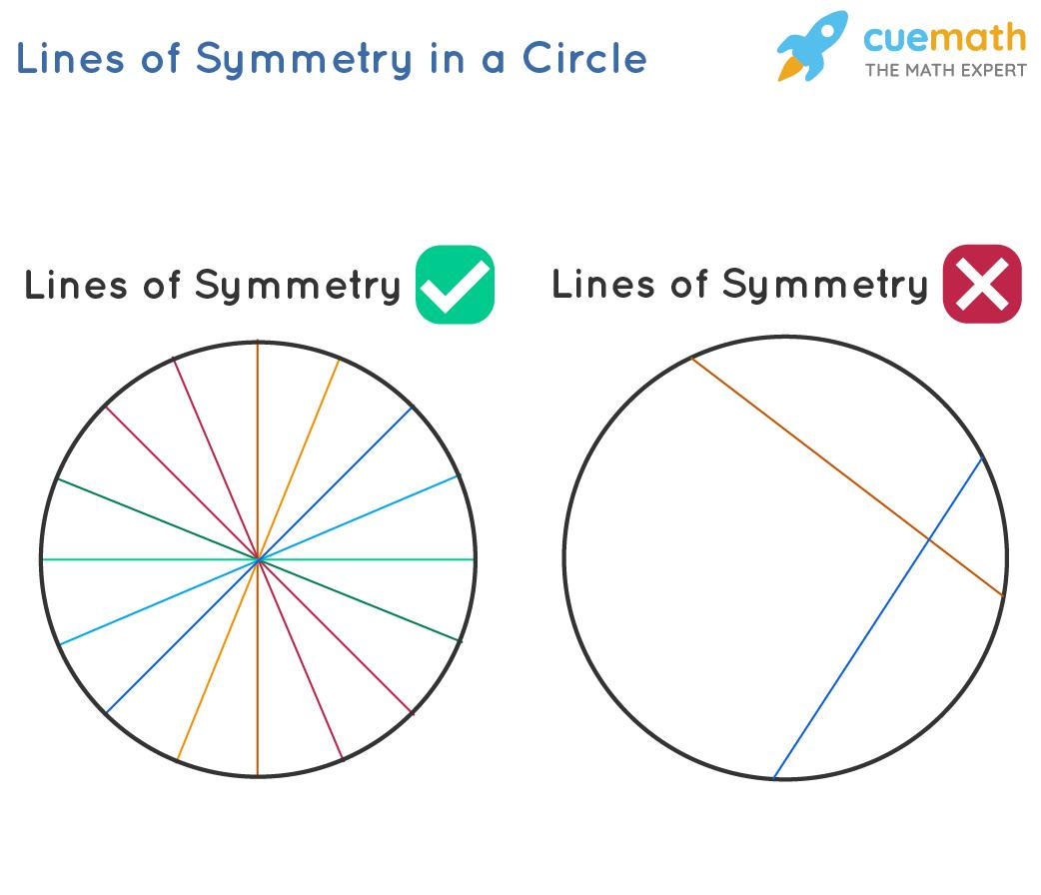
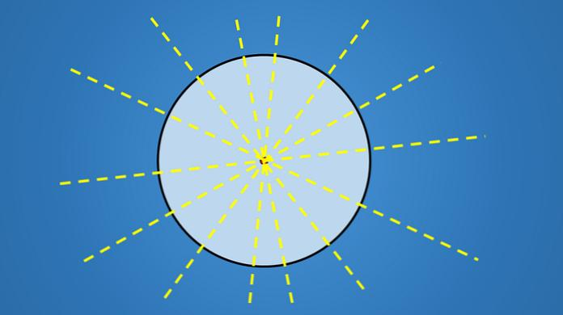
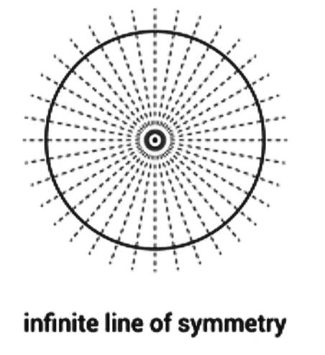

Rotational Symmetry Examples
# Source: AI Source: Provided by: [Data Path: Persons Table -> ID Column: 1, Name_En Column: Motasem Essam] -> From: [ChatGPT] on [7/25/2026]
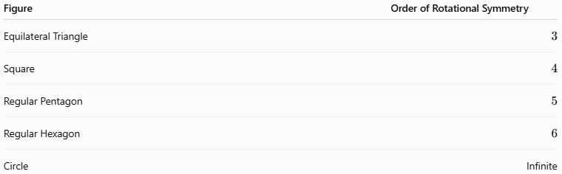
Figure | Order of Rotational Symmetry
Equilateral Triangle | $$3$$
Square | $$4$$
Regular Pentagon | $$5$$
Regular Hexagon | $$6$$
Circle | Infinite
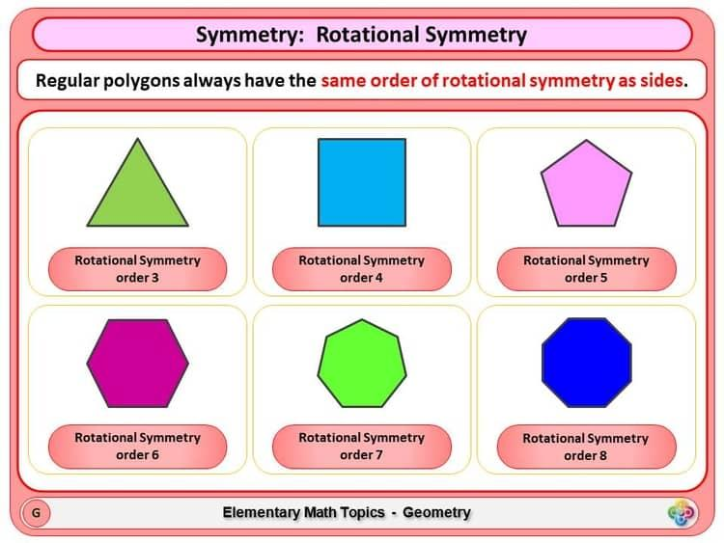
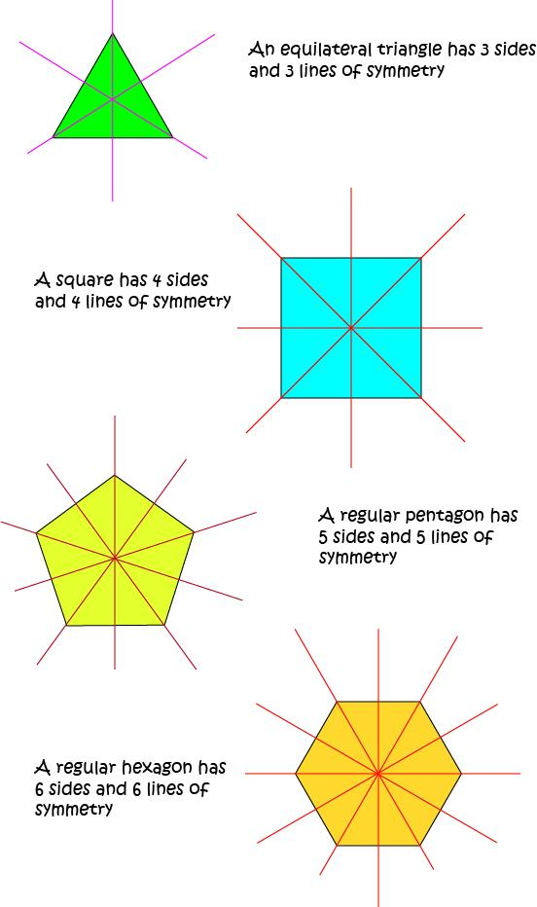
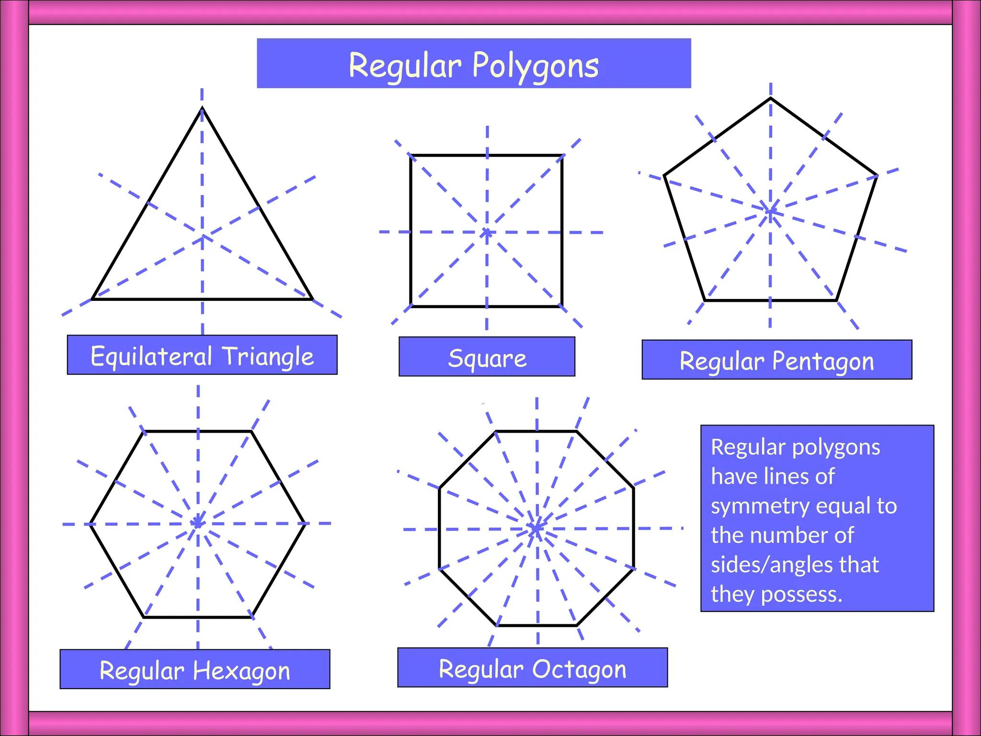
For a regular polygon with $n$ sides:
$$\boxed{\text{Order}=n}$$
The smallest angle of rotational symmetry is:
$$\boxed{θ=\frac{{360}^{∘}}{n}}$$

Symmetry of Common Figures
# Source: AI Source: Provided by: [Data Path: Persons Table -> ID Column: 1, Name_En Column: Motasem Essam] -> From: [ChatGPT] on [7/25/2026]
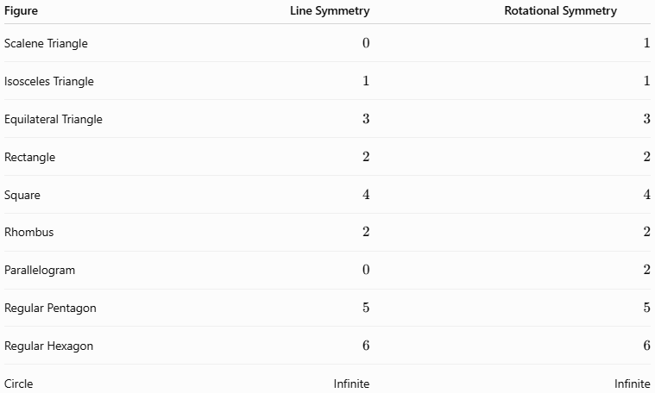
Figure | Line Symmetry | Rotational Symmetry
Scalene Triangle | $$0$$ | $$1$$
Isosceles Triangle | $$1$$ | $$1$$
Equilateral Triangle | $$3$$ | $$3$$
Rectangle | $$2$$ | $$2$$
Square | $$4$$ | $$4$$
Rhombus | $$2$$ | $$2$$
Parallelogram | $$0$$ | $$2$$
Regular Pentagon | $$5$$ | $$5$$
Regular Hexagon | $$6$$ | $$6$$
Circle | Infinite | Infinite
Note: Rotational symmetry of order $1$ means there is no non-trivial rotational symmetry before ${360}^{∘}$.

Symmetry and Congruence
# Source: AI Source: Provided by: [Data Path: Persons Table -> ID Column: 1, Name_En Column: Motasem Essam] -> From: [ChatGPT] on [7/25/2026]
Symmetry is closely related to congruence.
When a figure is reflected across a line of symmetry, the resulting image is congruent to the original figure.
Similarly, when a figure has rotational symmetry, the rotated image is congruent to the original.
Therefore:
$$\boxed{\text{Symmetry}⇒\text{Congruent Image}}$$
for these geometric transformations.
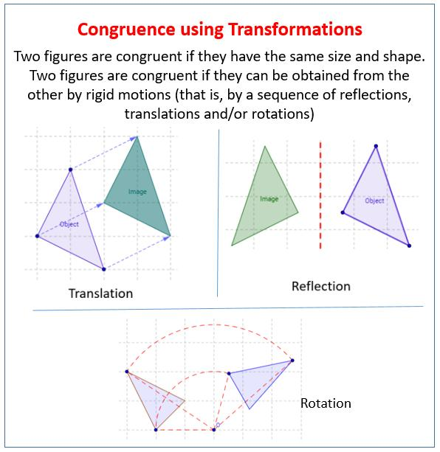
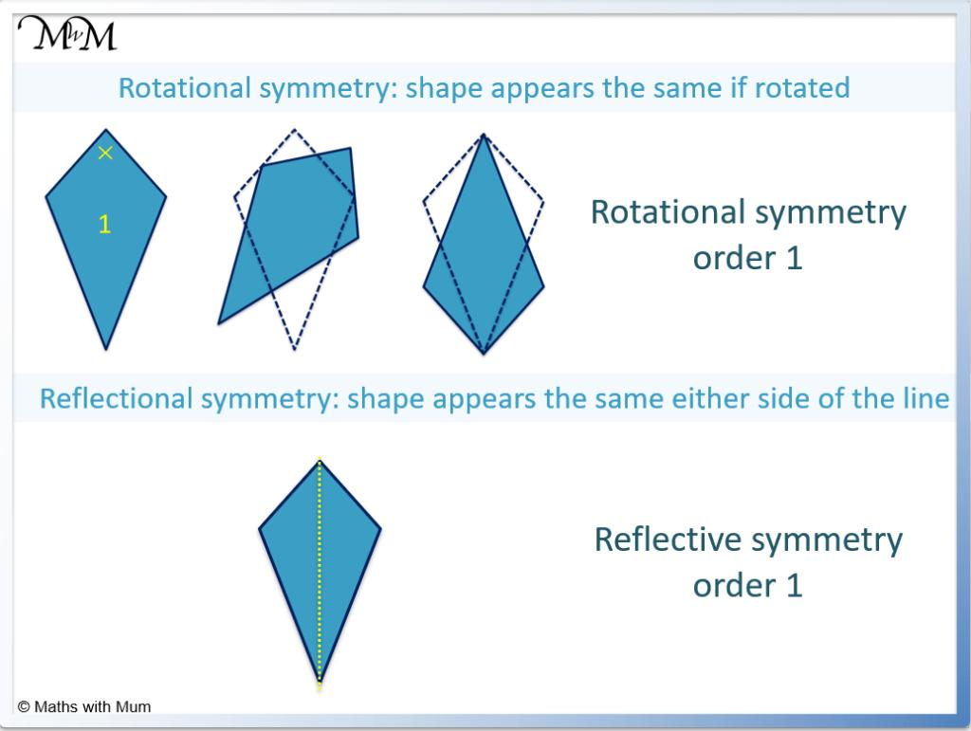
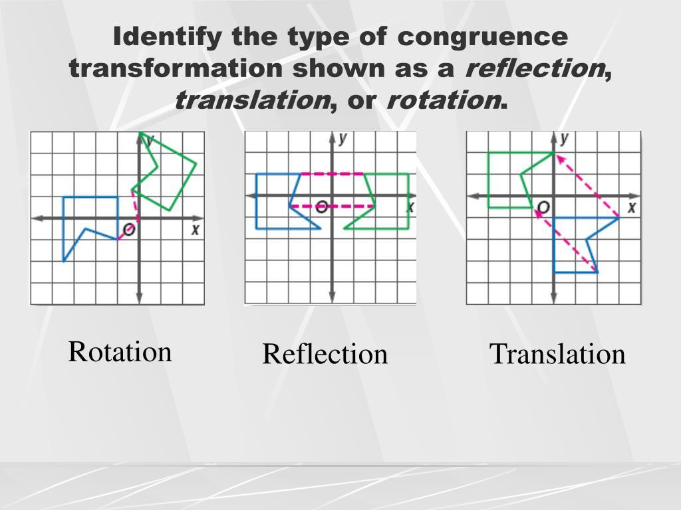
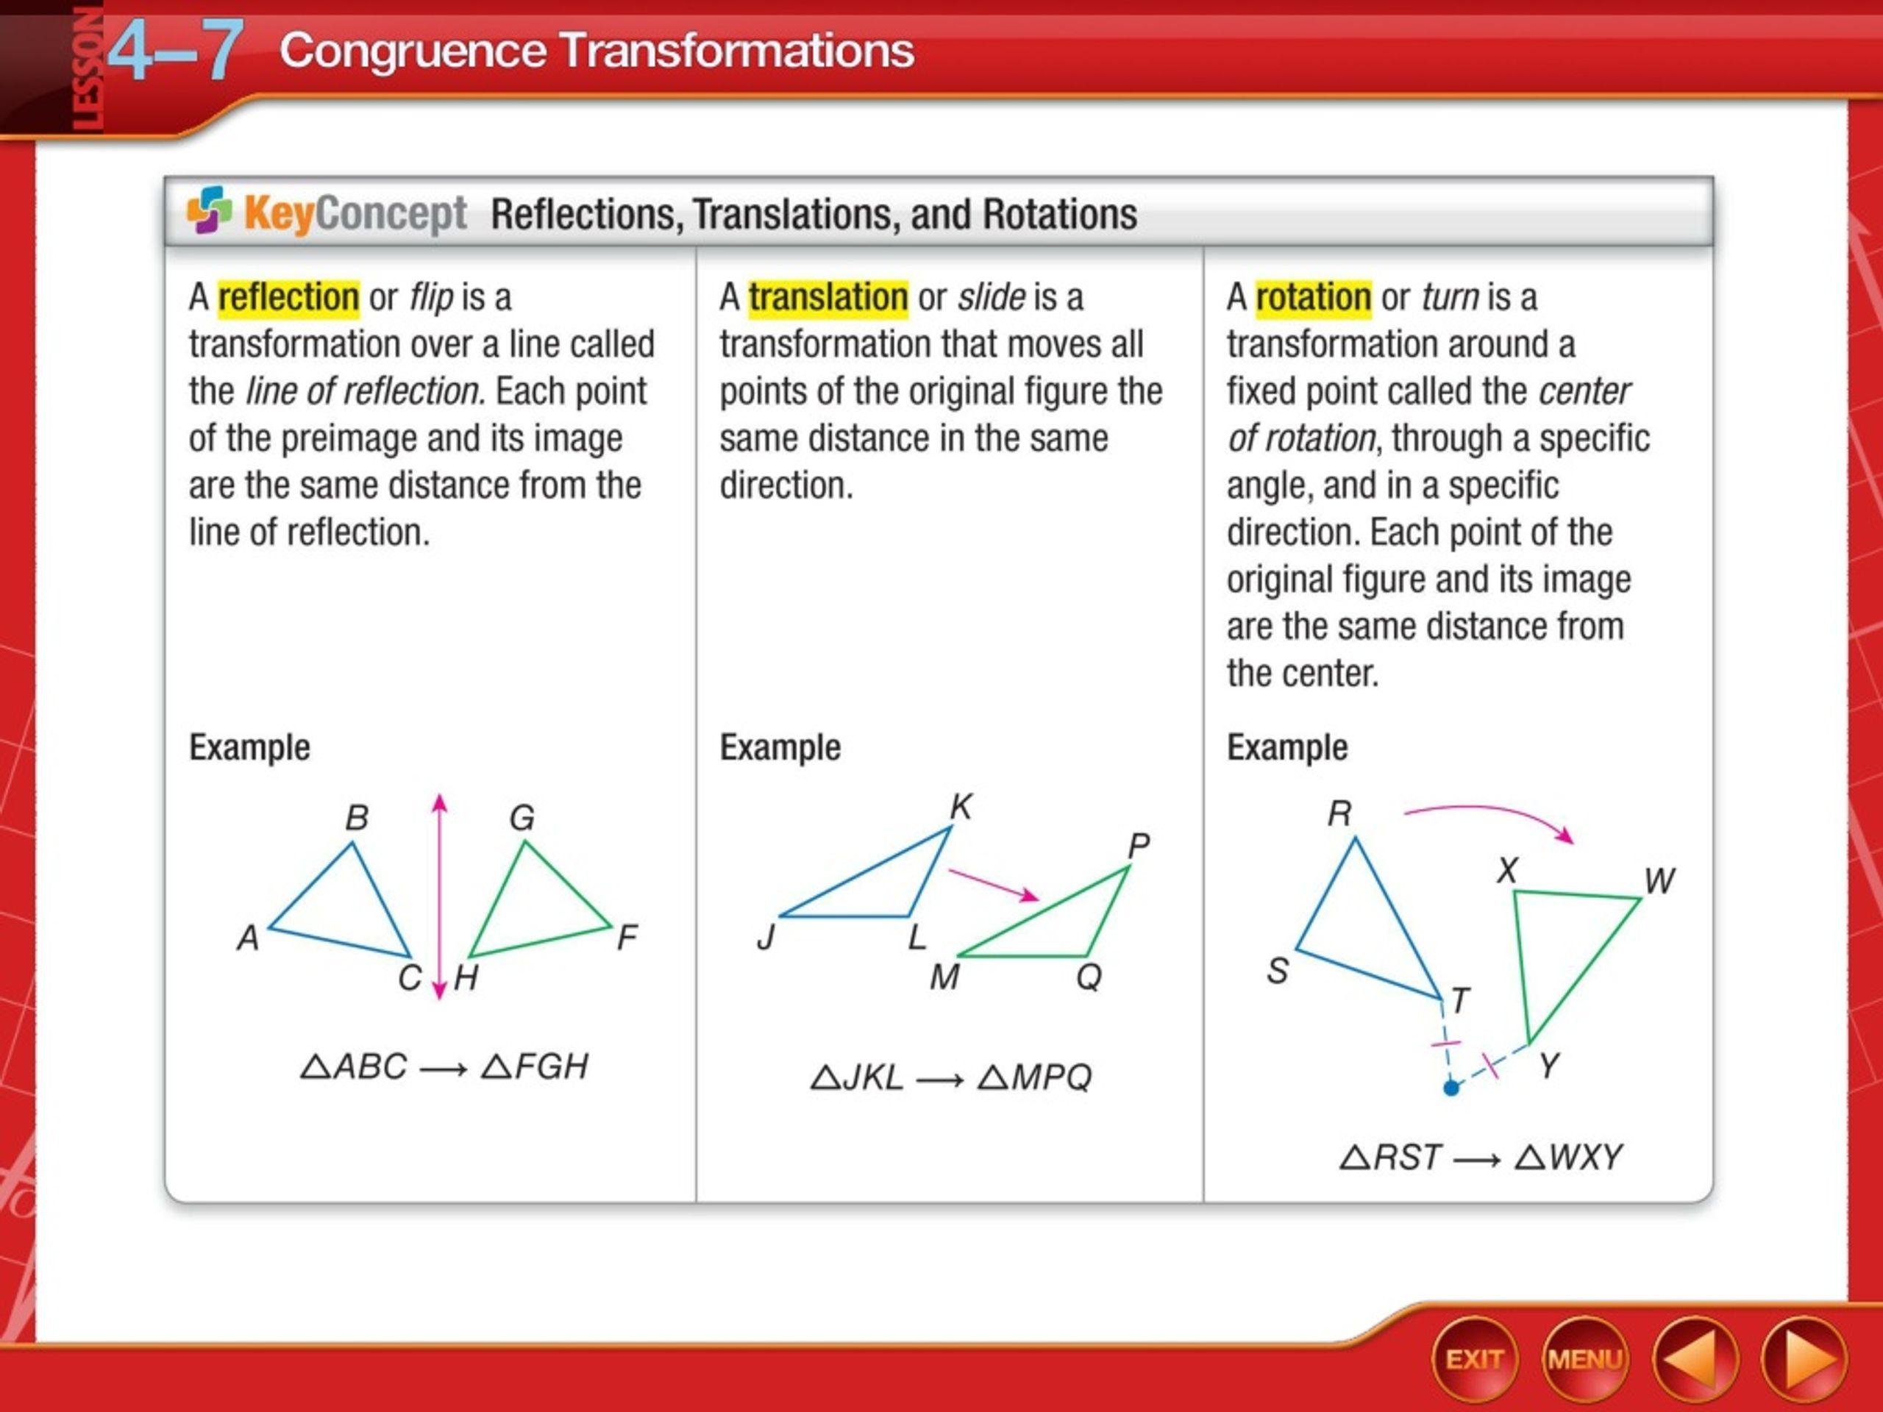
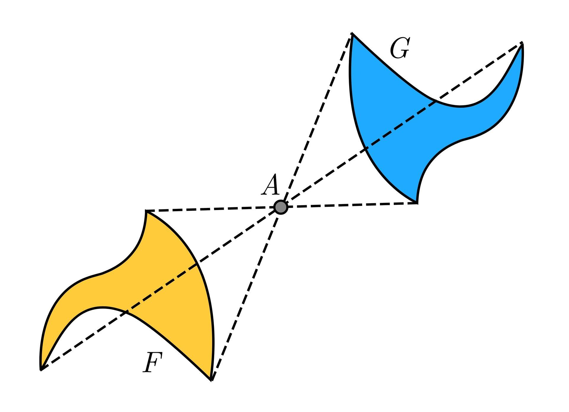
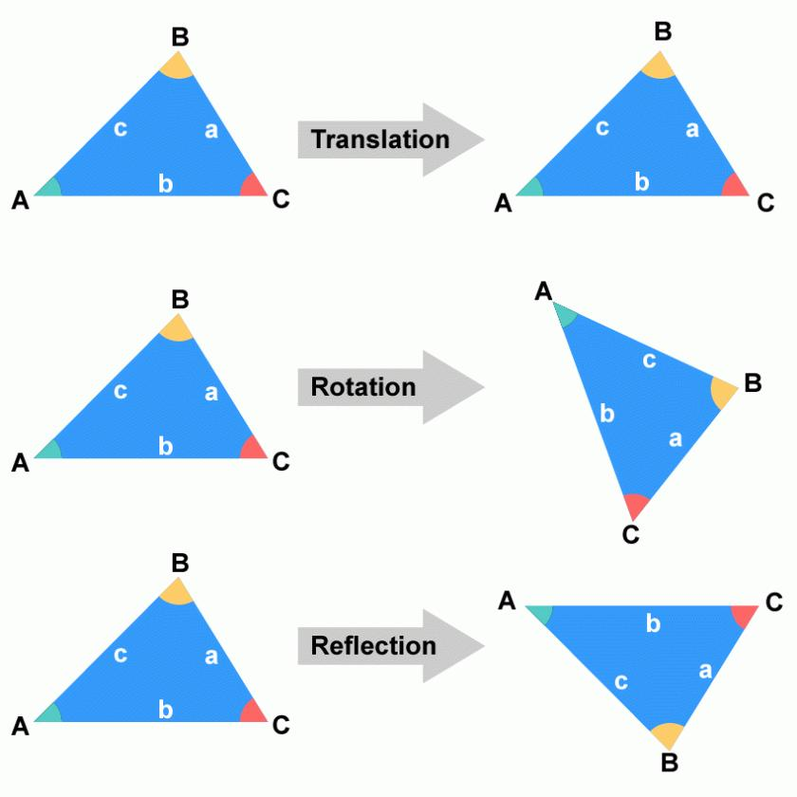

Symmetry and Similarity
# Source: AI Source: Provided by: [Data Path: Persons Table -> ID Column: 1, Name_En Column: Motasem Essam] -> From: [ChatGPT] on [7/25/2026]
Symmetry can also be viewed as a special case of similarity.
A symmetric figure maps onto itself without changing its size, so its scale factor is:
$$\boxed{k=1}$$
Therefore, a symmetric figure is mapped to a congruent and therefore similar image.

Symmetry and Coordinate Geometry
# Source: AI Source: Provided by: [Data Path: Persons Table -> ID Column: 1, Name_En Column: Motasem Essam] -> From: [ChatGPT] on [7/25/2026]
Symmetry can be studied using coordinates.
For example, reflection across the $y$-axis follows:
$$\boxed{\left(x,y\right)→\left(-x,y\right)}$$
Reflection across the $x$-axis follows:
$$\boxed{\left(x,y\right)→\left(x,-y\right)}$$
A figure has symmetry about the $y$-axis if its points occur in matching pairs:
$$\left(x,y\right) \text{and} \left(-x,y\right)$$
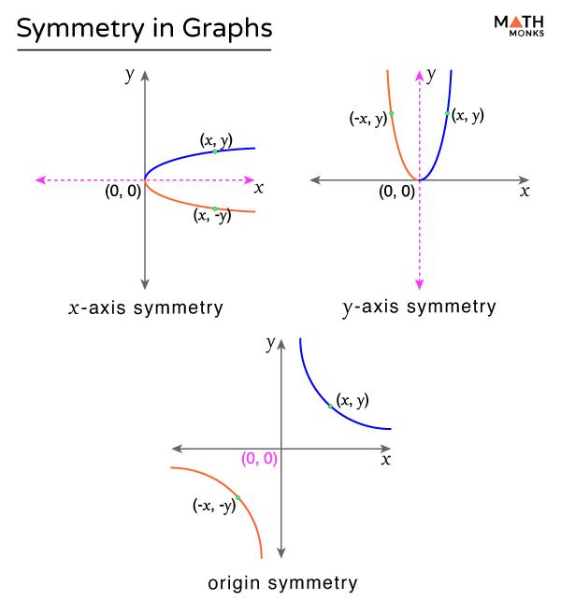
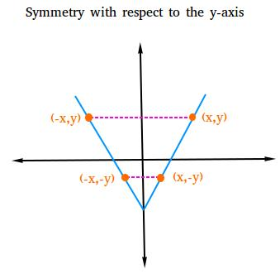
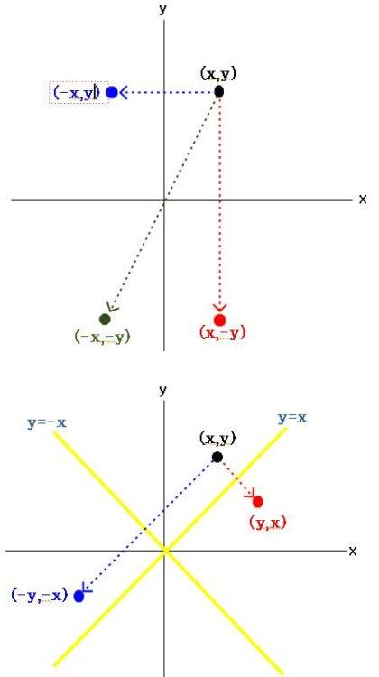
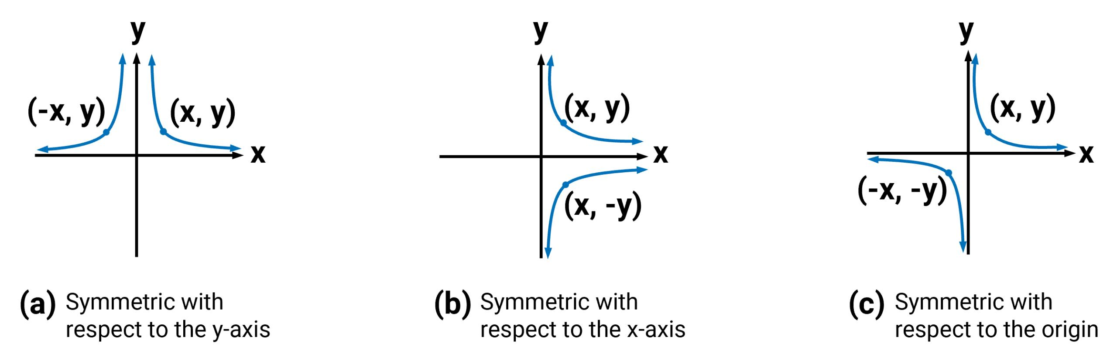

Symmetry in Nature
Symmetry appears frequently in natural forms.
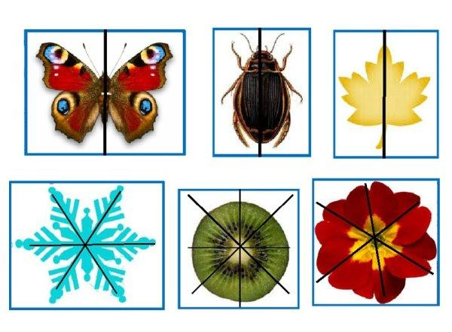
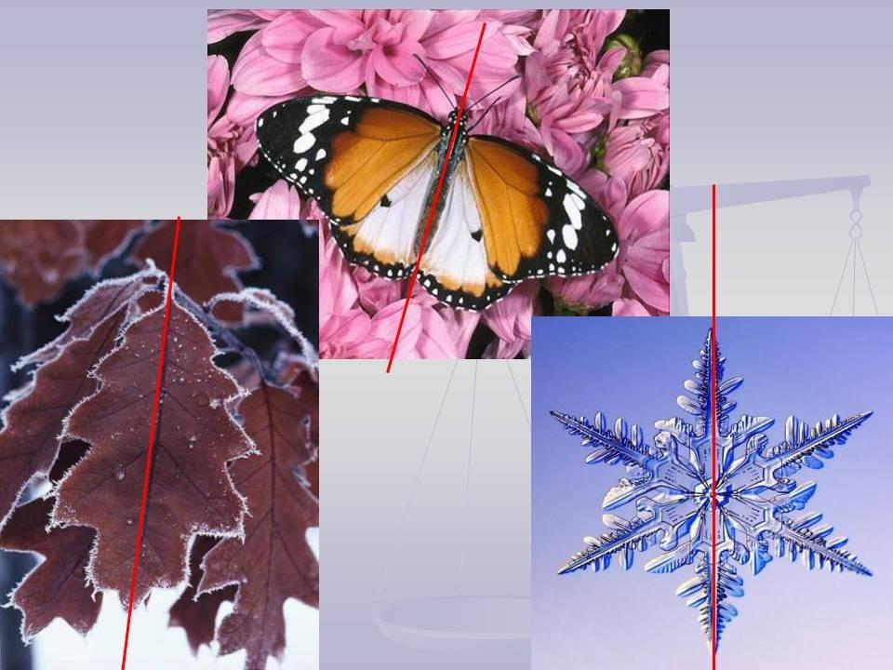
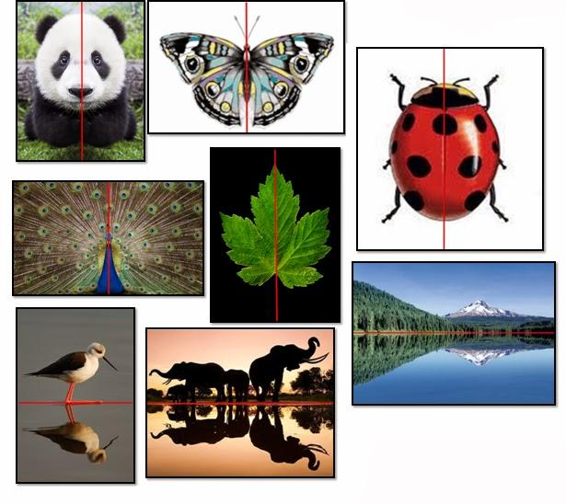
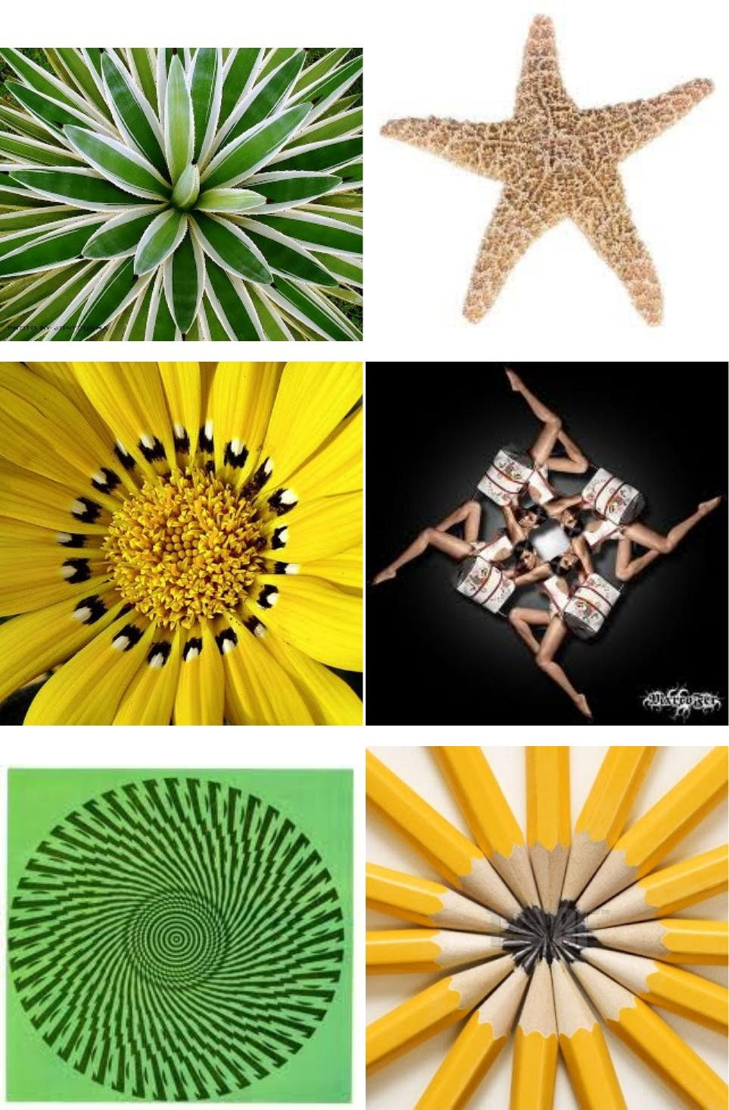
Examples include:
- Butterflies.
- Flowers.
- Snowflakes.
- Leaves.
- Human body structure.
- Some animals.
- Crystals.
Natural objects may have approximate rather than mathematically perfect symmetry.

Symmetry in Architecture and Design
# Source: AI Source: Provided by: [Data Path: Persons Table -> ID Column: 1, Name_En Column: Motasem Essam] -> From: [ChatGPT] on [7/25/2026]
Symmetry is widely used to create balanced and organized designs.
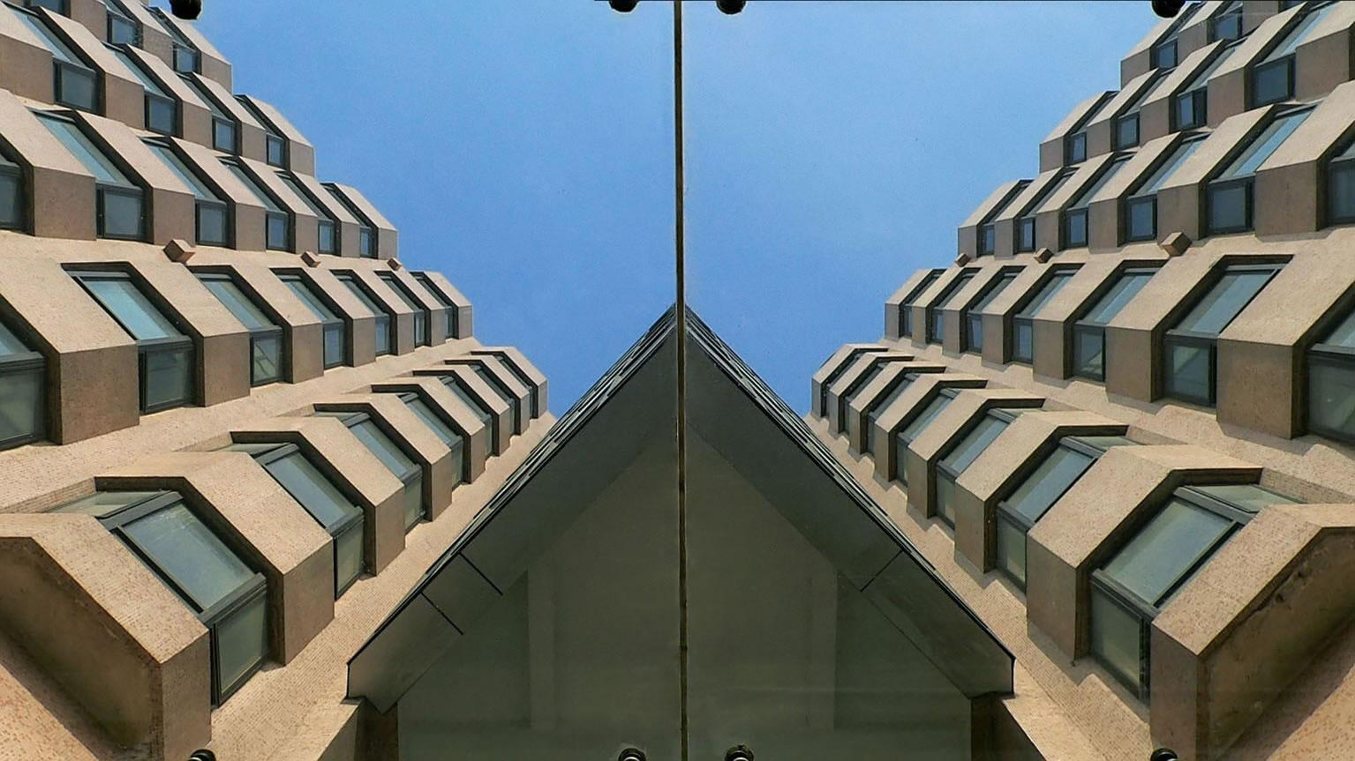
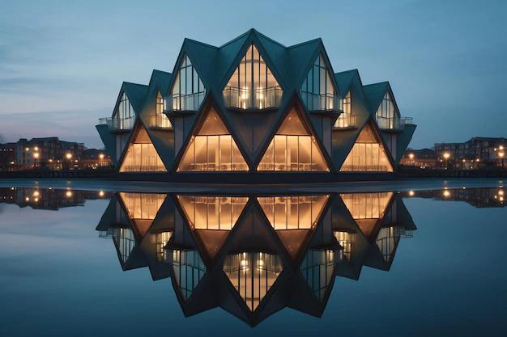


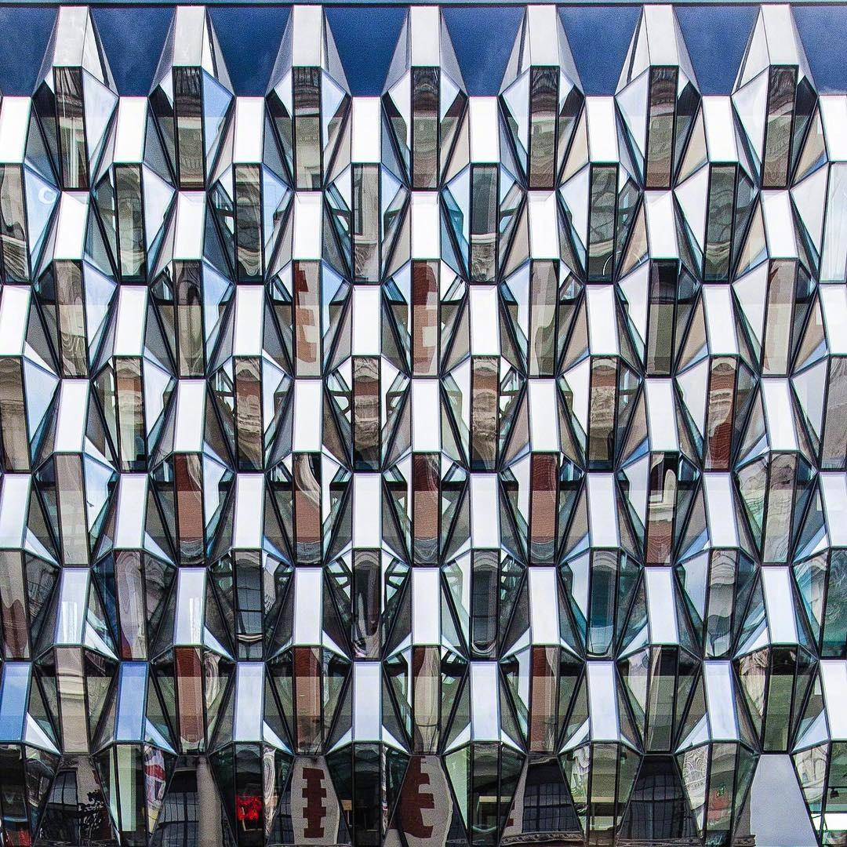
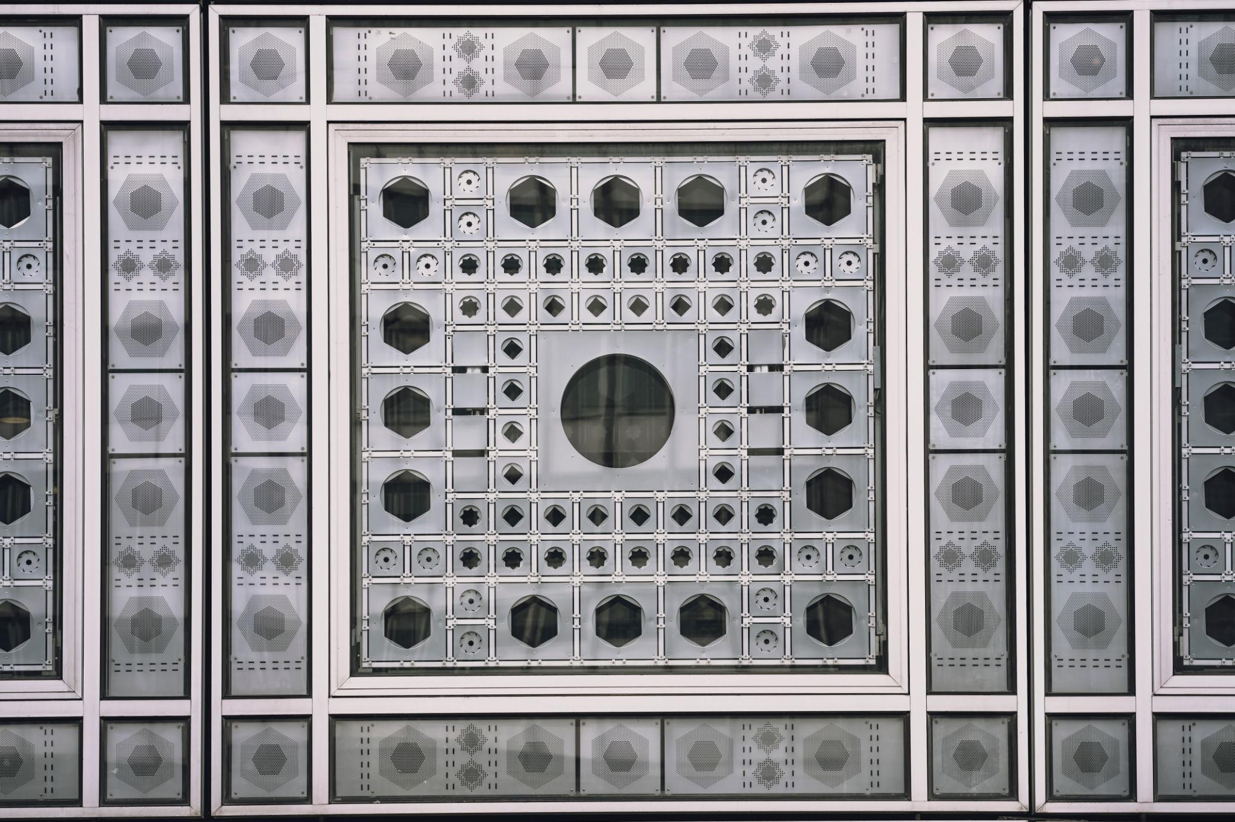
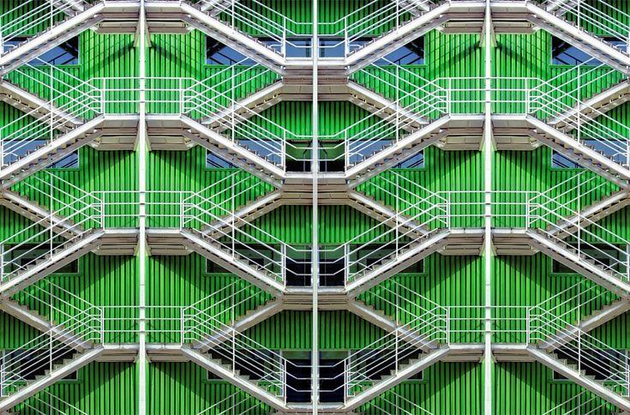

Applications include:
- Building facades.
- Doors and windows.
- Floor patterns.
- Decorative designs.
- Logos.
- Product design.
- Engineering structures.

Symmetry in Computer Graphics
# Source: AI Source: Provided by: [Data Path: Persons Table -> ID Column: 1, Name_En Column: Motasem Essam] -> From: [ChatGPT] on [7/25/2026]
Computer graphics frequently use transformations to create symmetrical objects.
For example:
- Create one part of an object.
- Reflect it.
- Combine the reflected parts.
This reduces the amount of work required to create a symmetric model.
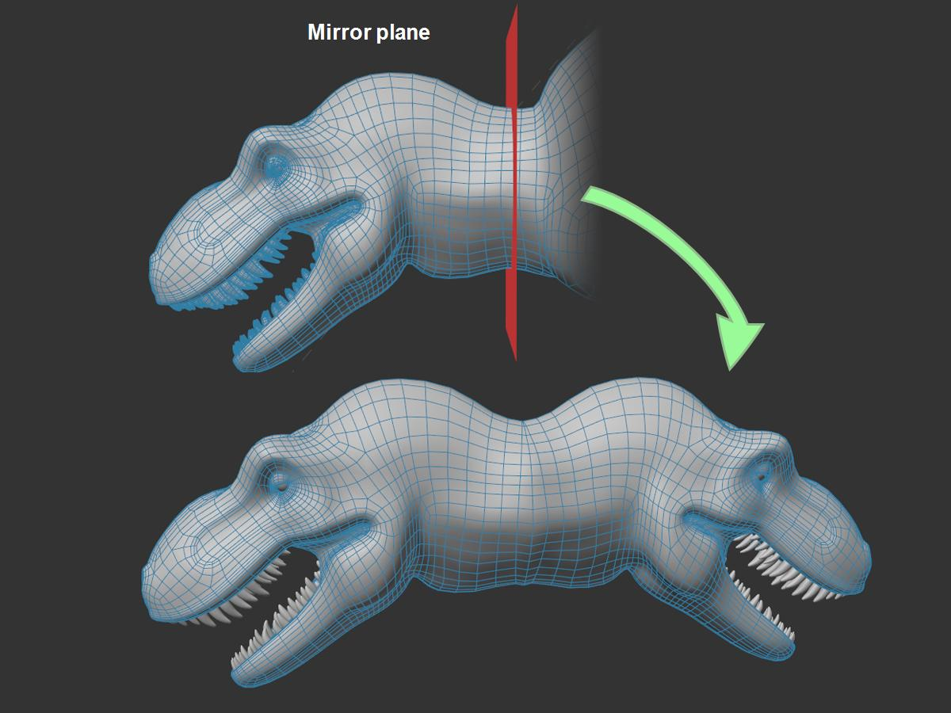
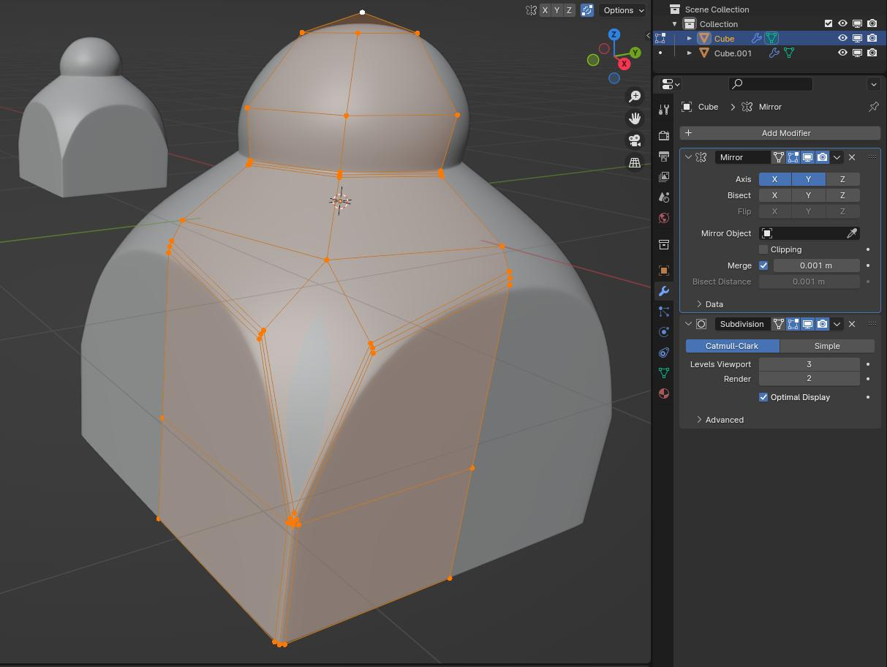
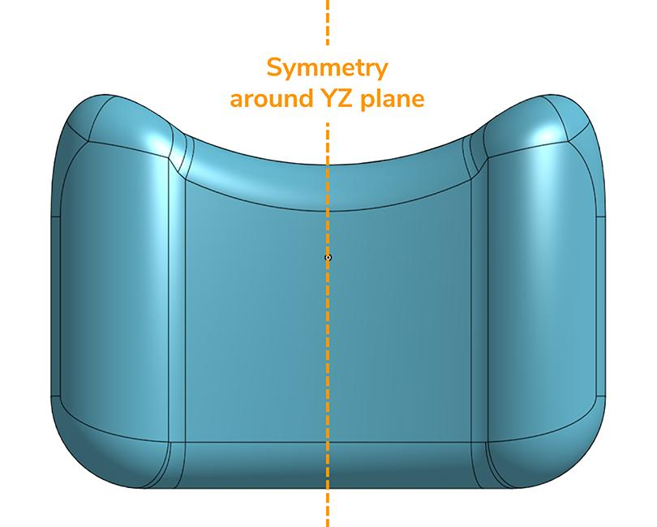
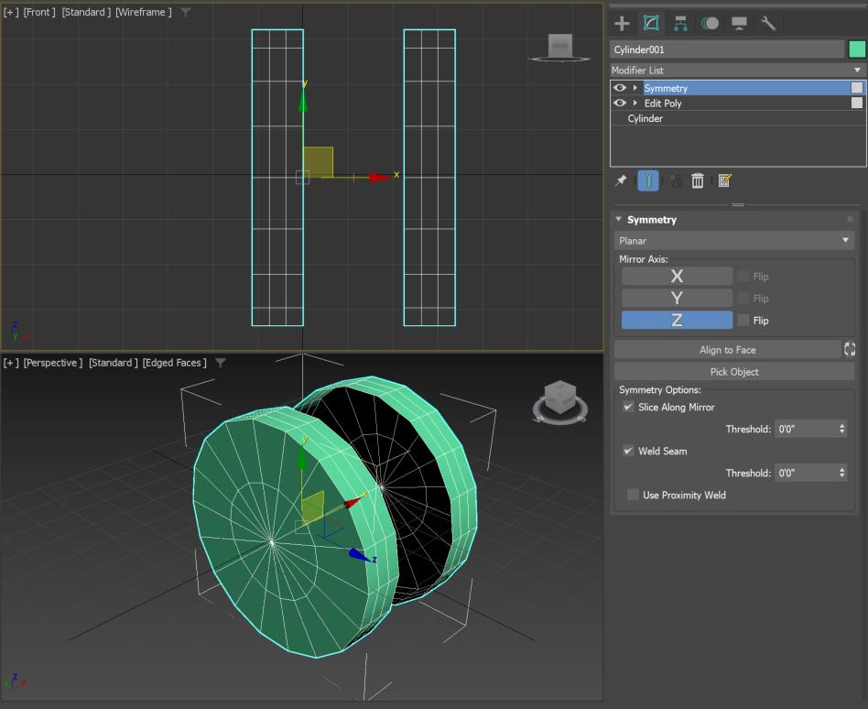
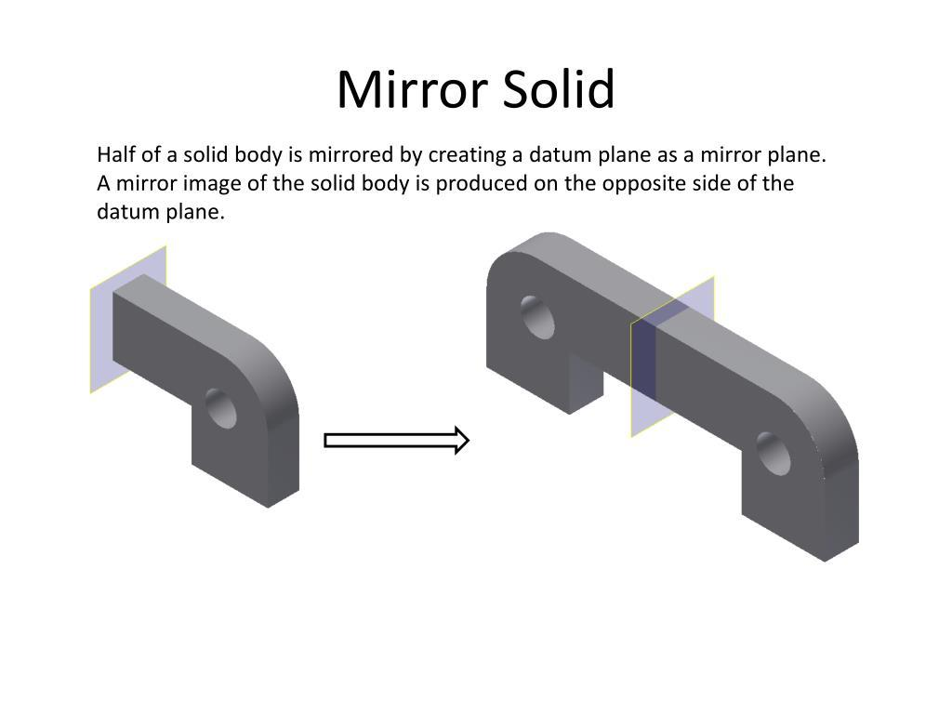

Applications
# Source: AI Source: Provided by: [Data Path: Persons Table -> ID Column: 1, Name_En Column: Motasem Essam] -> From: [ChatGPT] on [7/25/2026]
Symmetry is important in:
- Plane Geometry
- Geometric Transformations
- Coordinate Geometry
- Architecture
- Engineering
- CAD
- Computer Graphics
- Product Design
- Art
- Pattern Design
- Crystallography
- Physics
- Biology

Advantages
# Source: AI Source: Provided by: [Data Path: Persons Table -> ID Column: 1, Name_En Column: Motasem Essam] -> From: [ChatGPT] on [7/25/2026]
Studying symmetry helps to:
- Recognize balanced geometric structures.
- Understand transformations.
- Analyze geometric figures.
- Identify repeated patterns.
- Simplify geometric constructions.
- Create efficient designs.
- Understand natural structures.
- Develop spatial reasoning.
- Support computer modeling and graphics.

Limitations
# Source: AI Source: Provided by: [Data Path: Persons Table -> ID Column: 1, Name_En Column: Motasem Essam] -> From: [ChatGPT] on [7/25/2026]
Symmetry:
- Does not mean that every part of a figure must be identical in all respects.
- Some figures have no symmetry.
- Real-world objects may only be approximately symmetric.
- Complex figures may have multiple types of symmetry.
- Determining symmetry can become difficult for irregular shapes.

Comparison with Related Concepts
# Source: AI Source: Provided by: [Data Path: Persons Table -> ID Column: 1, Name_En Column: Motasem Essam] -> From: [ChatGPT] on [7/25/2026]
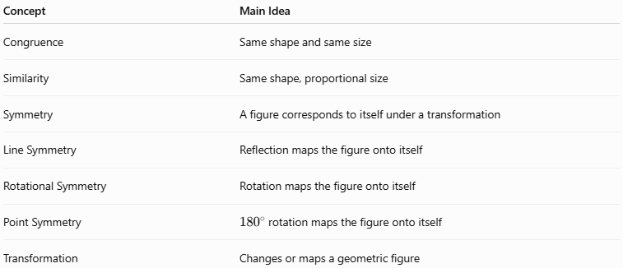
Concept | Main Idea
Congruence | Same shape and same size
Similarity | Same shape, proportional size
Symmetry | A figure corresponds to itself under a transformation
Line Symmetry | Reflection maps the figure onto itself
Rotational Symmetry | Rotation maps the figure onto itself
Point Symmetry | (180^\circ) rotation maps the figure onto itself
Transformation | Changes or maps a geometric figure

Key Points
# Source: AI Source: Provided by: [Data Path: Persons Table -> ID Column: 1, Name_En Column: Motasem Essam] -> From: [ChatGPT] on [7/25/2026]
- Symmetry describes a balanced correspondence within a geometric figure.
- A figure has symmetry when a suitable transformation maps it onto itself.
- The major types include:
  - Line Symmetry
  - Rotational Symmetry
  - Point Symmetry
- Line symmetry is associated with reflection.
- Rotational symmetry is associated with rotation.
- Point symmetry corresponds to a (180^\circ) rotation.
- A square has:
[
4\text{ lines of symmetry}
]
and:
[
4\text{th-order rotational symmetry}
]
- A circle has infinitely many lines and rotational symmetries.
- Symmetry is widely used in geometry, architecture, engineering, design, nature, and computer graphics.

Conclusion
# Source: AI Source: Provided by: [Data Path: Persons Table -> ID Column: 1, Name_En Column: Motasem Essam] -> From: [ChatGPT] on [7/25/2026]
Symmetry is a fundamental type of Geometric Relationship that describes the correspondence of a figure with itself under a geometric transformation. The main forms of symmetry include line symmetry, rotational symmetry, and point symmetry. Line symmetry is produced by reflection, rotational symmetry by rotation, and point symmetry by a (180^\circ) rotation. Symmetry provides an important way to analyze geometric figures, recognize patterns, understand transformations, and create balanced structures in mathematics, architecture, engineering, art, nature, and computer graphics.

